SPIRIT ALIVE
St. Bernard Confirmation Preparation:
A Guide to Live Out the New Evangelization through the Sacrament of Confirmation and a New Life in the Holy Spirit*
*Based on “Catholic Faith in Action: A Means to Live Out the New Evangelization” from the Catholic Diocese of Peoria, IL, developed for the 2015-2016 Confirmation Program for St. Bernard Parish, Diocese of Green Bay, WI

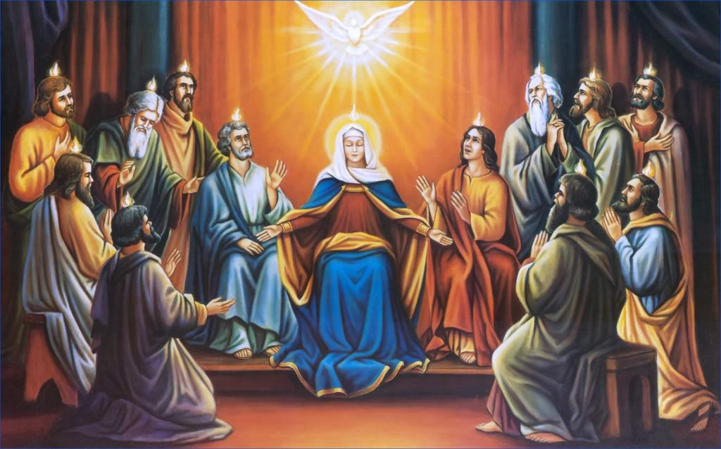

St. Bernard Parish
2040 Hillside Lane, Green Bay, WI 54302
Website: www.stbernardgb.org
(920) 468-4811
Coordinator: Callie Kowalski
callie@stbernardcong.org
(920) 468-4811, ext. 117
www.stbernardconfirmation.weebly.com
Purpose & Preface

The purpose of Spirit Alive is twofold: to facilitate metanoia for individuals and to initiate involvement in evangelization and discipleship. Metanoia is a Greek word used in the gospels described as “a radical conversion, a profound change of mind and heart” [EN 10]. A transformation is necessary to become a true disciple of Christ. What happens to an individual is vitally important because of what should emerge from metanoia – the desire to tell others. Telling others is the simplest form of evangelization. This has been the Catholic Church’s mission since its beginning and Pope Paul VI reminds us in his Apostolic Exhortation, Evangelii Nuntiandi [On Evangelization in the Modern World], that the “key words of Jesus Christ’s evangelization, are available to every human being as grace and mercy” [EN10]. As Catholic Christians, we should experience metanoia in order to bring those around us closer to Christ and his Church.

- Catholic Faith in Action, in which Spirit Alive was developed from, was set in motion in the late 1970’s when Deacon Gregory L. Serangeli supplemented the Life in the Spirit Seminar by incorporating Scripture readings and journaling as homework assignments for Seminar participants to do and then share at their next seminar meeting. A handout was developed that included a teaching as well as daily readings of Scripture focusing on the themes of the seminar to be journaled. The Life in the Spirit Seminars began with the team presenting a New American Bible and a spiral notebook for journaling to the participants. The Catholic Charismatic Renewal Office adapted the practice through its promotion and presentation of Life in the Spirit Seminars throughout the diocese.

- During the 1990’s, Msgr. Thomas Monahan of the Rockford Diocese advised Deacon Greg to uphold the Charismatic Renewal in a “fully Catholic and fully Charismatic” manner. To carry out this counsel meant a revision of Catholic Faith in Action to convey its fully Catholic intent and incorporate doctrine from the Catechism of the Catholic Church. In revising the supplement to the Life in the Spirit Seminar, Deacon Greg teamed up with Deacon Robert J. Pomazal. Deacon Bob added the Catechism references to be used with journaling and updated the Catholic Faith in Action program.

Under the direction of Deacon Bob, the St. Edward’s Prayer Group in Chillicothe took the Catholic Faith in Action Seminar to parishes and vicariates during 1998, the “Year of the Holy Spirit”

Callie Kowalski, Coordinator of Confirmation at St. Bernard Parish in Green Bay, came across Catholic Faith in Action and adapted it for a high school, Confirmation preparation program.
Additional reference materials:
On Evangelization in the Modern World (Evangelii Nuntiandi) - Apostolic Exhortation of Pope Paul VI, (December 8, 1975). Available from: http://www.vatican.va/holy_father/paul_vi/apost_exhortations/documents/hf_p-vi_exh_19751208_evangelii-nuntiandi_en.html
Go and Make Disciples, A National Plan and Strategy for Catholic Evangelization in the United States
United States Conference of Catholic Bishops, the Committee on Evangelization, November 18, 1992. http://www.usccb.org/evangelization/goandmake/index.shtml
Chariscenter USA

The National Service Committee is a body of leaders in the Catholic Charismatic Renewal who work together to serve the Lord in renewing the grace of Pentecost in the life and mission of the Church. http://www.nsc-chariscenter.org/
Catechism of the Catholic Church (2nd Ed.) 1997. United States Conference of Catholic Bishops. http://www.usccb.org/catechism/text/

Invitation

Spirit Alive is an invitation to get to know and experience the Holy Spirit in a deeper way, particularly through the receiving of the Sacrament of Confirmation, and is extended to all believers in Jesus Christ. It is an opportunity for spiritual growth through learning about the different aspects of the Holy Spirit and our faith. The only thing necessary for this process is openness to the movement of the Spirit.

In order to prepare individuals for more activity and experiences with the Holy Spirit, the Spirit Alive program is presented in eight class-sessions with a series of talks and discussions. The first week is an introduction to the program, which is a fully-Catholic adaptation of the Life in the Spirit Seminar, in addition to the Confirmation requirements presented by Bishop David Ricken and the Diocese of Green Bay. Please be advised that the class schedule and calendar will be provided for in a different document. Topics include the following:

Class 1 - Introduction to Spirit Alive series
Class 2 - God's Love
Class 3 - Salvation
Class 4 - Preview of the New Life in the Spirit
Class 5 - Receiving God's Gift
Class 6 - Release of the Holy Spirit
Class 7 - Growth Through Ongoing Conversion
Class 8 - Transformation in Christ

One opportunity during the series is for participants to receive what Jesus described in Acts 1:4 as “the promise of the Father,” a release of the power of the Holy Spirit. Following an introductory overview, the next four sessions prepare participants for this transforming event, while the last two sessions provide the guidance needed to integrate this yielding to the Holy Spirit into their daily lives and their local parish community.
More of the Holy Spirit
During the Last Supper, Jesus assured His disciples, “I will pray to the Father and He will give you another Advocate (Counselor), to be with you forever” (John 14:16). Jesus knew when He was no longer on earth, His disciples, limited to their own strength and ability, would not be able to live the kind of life to which He had called them. He pledged to them the very Spirit of God as a helper. Ten days after Jesus ascended into Heaven, and on the Jewish feast of Pentecost, the Holy Spirit assuredly came down upon and filled each of them with Himself. Ever since that time, the third person of the Trinity has remained with the Christian people. We celebrate this event every year on Pentecost as the birthday of our Catholic Church. When Pope John XXIII convened the Second Vatican Council in 1963, he prayed,
“Renew in our day, O Lord, your wonders as in a new Pentecost.”

His prayer was answered because the new Pentecost has been happening. Just as those 120 men and women who were gathered at that Jewish feast over 2,000 years ago were transformed and empowered for their witness and mission, Catholic Christians today are also experiencing the Holy Spirit in a transforming and empowering personal Pentecost.

This experience of a personal Pentecost is a renewal of an individual. It is deemed an integral part of the renewal of the Church, which was initiated with Vatican II.
- Pope Francis, in his homily on the feast of Pentecost in 2013 shared, “Although the events of Pentecost took place almost 2,000 years ago they are not something far removed from us; they are events which affect us and become a lived experience in each of us. The Holy Spirit makes us look to the horizon and drives us to the very outskirts of existence in order to proclaim life in Jesus Christ. Let us ask ourselves: Do we tend to stay closed in on ourselves, on our group, or do we let the Holy Spirit open us to mission?”

- Pope Emeritus Benedict XVI pointed out what is occurring within the Church when he said, "What the New Testament describes ... as visible signs of the coming of the Spirit is no longer merely ancient, past history: This history is becoming a burning reality today."

- Saint John Paul II praised the Pentecost renewal when he said, "The vigor and fruitfulness (of this renewal) attests to the powerful presence of the Holy Spirit at work in the Church."

- Archbishop John Myers, Archdiocese of Newark, extolled the prayer labors when he said, “This is one of the many authentic prayer movements in the Church initiated and sustained by the Holy Spirit.”

Building on the sacramental life of the Church, the Holy Spirit received in Baptism is being "fanned into flame," (2 Timothy 1:6). The flame is showing what Pope Benedict describes as “a burning reality” with confirmable results. This series will allow students to deepen their relationship with the Holy Spirit in order to fully receive the Spirit at Confirmation. Catholics filled with and led by the Holy Spirit are living a more deeply committed Christian life and each candidate of Confirmation is called to this. They are called to receive and use the gifts of the Holy Spirit, and contribute to a stronger spiritual life in Christian community within the universal Church.

Confirmation Saints & Sponsors (See Appendix B)

Confirmation candidates are required to choose a new Confirmation name. This name symbolizes the completion of Baptism through Confirmation where each candidate is called to be a NEW CREATION in Christ and through the Holy Spirit. In the Bible and the Early Church, a new name represented a new phase in one's life with a great devotion to God. Candidates may choose to use their Baptismal (first) name, or they may choose the name of the saint they wish to adopt as their patron (role model). The saint chosen is often one the candidate admires or has a devotion to and should be of the same gender as the candidate.

This journey isn’t meant to be walked alone. Candidates are required to choose a Confirmation sponsor who should be present to them during the course of this formation process. A sponsor must be over the age of 18, and a Confirmed and practicing Catholic. The sponsor should not be one of the candidate’s parents. More information about this can be found on the website.

Historical Note with Format Overview

The Spirit Alive series is a Catholic adaptation of a highly successful series known as the Life in the Spirit Seminar in addition to the Diocese of Green Bay requirements for receiving the Sacrament of Confirmation.

History of Life in the Spirit Seminar
The Life in the Spirit Seminar began in the early 1970’s shortly after the birth of the Charismatic Renewal at Duquesne University. For over 30 years these structured seminars provided the background and guidelines for teams of individuals to help others experience the release of the Holy Spirit, or as it is also called, the baptism in the Holy Spirit. In the early days, Catholics who experienced this release were sometimes referred to as Catholic Pentecostals because charisms (or gifts of the Holy Spirit) are released which were just as those experienced at Pentecost (Acts 2). The early references to Catholic Pentecostals often created misunderstanding with more traditional spiritualties within the Church. Now, the expression for Catholics receiving the baptism in the Holy Spirit is commonly termed, “charismatic.” The movement of the Holy Spirit in this way is manifested at the heart of the Catholic Church and identified as the Charismatic Renewal.

How Spirit Alive was developed
A team manual, first published in 1971, established the pattern for the Life in the Spirit Seminar. In 1979, a Catholic Edition emerged, and in 2000, a second edition was published. In parallel with these developments, the prayer group at St. Edward Church in Chillicothe, IL, successfully built upon the manuals and advanced a new program called Catholic Faith in Action. This program brings a Catholic emphasis and consciousness with an inclusion of the Mass, Eucharistic adoration, the Catechism of the Catholic Church and other Catholic traditions while retaining the essential structure and outlines of the topics contained in the Life in the Spirit model. From here, that program was developed to serve the candidates of Confirmation at St. Bernard Parish in Green Bay, WI.

Following the first Introduction class, the format for Spirit Alive consists of seven class-sessions lasting about 75-minutes. Each session is organized as follows:

15 minutes - Opening prayer plus praise and worship

15 minutes - Talk given by a team member (with possible brief witness talk to reinforce the topic of the session)

25 minutes – Small group discussion

10 minutes – Brief large group discussion
10 minutes – Wrap-up, review assignments & announcements for next class

Because the readings and journaling address the topic of the session talk, it is preferable to distribute each assignment prior to the class. One successful way to accomplish this is to schedule the introductory session where the program is outlined and the first assignment is distributed. This brings the actual program time commitment to eight class sessions.

Each student will receive a binder with all of the necessary class items. This binder should be brought to every class.

Spirit Alive
Class 1 - Introduction Session

Praying with Scripture, Journaling, and Study

As we begin the Spirit Alive series, we will be using the Bible as a significant resource for growing in our understanding and love of God. The Father, the Son, and the Holy Spirit want to reveal themselves to you during these next seven classes. It is for this reason that we should become dedicated to reading the assigned Scripture passages each day and meditating upon them.

Students will need to provide their own Bible. This Bible will be used quite frequently for supplemental work outside of class. The edition we will be using is the New American Bible (NAB), a reliable translation of the Bible commonly used for Sunday Masses.

As you begin to pray with Scripture, the following thoughts and guidelines may be helpful:

1. Spend Some Time Getting Ready
Try to set aside a quiet time each day when you are most alert, preferably the same time each day. Allow about fifteen minutes to a half an hour, or more. What you do immediately before prayer is important. Normally, this is something we should not rush into. Spend a few moments quieting your mind and relaxing, settling into a prayerful but comfortable position.

When listening to anyone, whether it is another person or God, we should try to tune out everything except what the person is saying to us. In prayer, this is done best in silence and solitude since God usually speaks softly, and the world around us is quite loud. A quiet space is the ideal environment; however, it may not be possible because of the noise and activity of our lives. Do the best you can and know that success in gaining quiet time takes practice. Also, keep in mind that it is not necessary to exclude all thoughts of our commitments and activities of our lives. Anxiety in this regard could become a distraction itself. Try to ignore distractions rather than attacking them head-on.

Remember too, that God reveals himself in ways other than through Scripture. Sometimes in preparation for prayer we can yield to His presence around us: listen to spiritual music, smell the coffee or candle, feel the upholstery against our skin. God's presence is as real as the things around us are.
- Begin your prayer time by thanking Jesus for some particular blessing you recognize in your life. Or, if you can't think of anything in particular, just thank Him for giving you this quiet time. This does not have to be a long prayer. For instance, "Thank You, Jesus, for the getting me through that test at school.” You are developing an intimate relationship with the Lord so feel free to use your own words and avoid "churchy" sounding prayers, unless this is the way you always talk. As you become accustomed to praying this way, you will begin to experience a growing desire to simplify your prayer and simply praise and thank the Lord.
- Next, ask the Father for forgiveness of any particular area of sin in your life. This time is not meant to be spent in an extensive examination of conscience. Rather, it is a simple acknowledgment of our sinfulness made specific by asking for forgiveness of the most recent or most conscious sins. Just be humble and honest with our Lord. After asking for the Father's forgiveness, be sure to thank him for his endless mercy.

These preparatory steps help to free us from distractions and obstacles that might keep us from hearing God's message in His Holy Word.

Now, ask that the Holy Spirit will be present in your heart and mind to guide you in your understanding and acceptance of what God is saying to you in the particular passage that you are about to read. Also, ask the Holy Spirit to protect you from any deception by the evil one.

Now you are ready to begin reading the passage of Scripture for the day.

2. Listen as You Read God's Word

God invites us to listen as we read His Word. This is the basic attitude of prayer. Ask God for the grace to hear what He says.

Begin reading Scripture slowly and attentively. Do not rush.

After you have read the passage once, go back and read it a second time. In the second reading, picture in your mind that Jesus, the Son of God, is speaking directly to you, alone. Take in the passage and let it come alive within you.

- If the passage recounts an event of Christ's life, imagine yourself in the scene, itself. Share mentally with the people and apostles involved. Respond to what Jesus is saying.
- There might be a word or phrase that hits you. Focus on that.

At times, you will become aware of things and experience feelings that catch your attention. They may be very profound, but normally, you will sense subtle impressions such as:

- you feel a special closeness to Christ,
- you experience God's love,

- you feel spiritually uplifted,

- you are moved to do something,

- you feel peaceful,

- you are happy and content just to be in God's presence.

This is the time to pause. This is God speaking directly to you in the words of Scripture. Do not hurry to move on. Wait until you are no longer moved by what you are experiencing.

On the other hand, don't get discouraged if nothing seems to be happening. Sometimes God lets us feel dry and empty in order to let us realize it is not in our own power to communicate with Him or to experience consolation. God is sometimes very close to us when we don’t physically feel him there.
A humble attitude of listening is a sign of love for Him and a real prayer from the heart. This method of using our imagination when we read Scriptures (meditation) is at times difficult and slow, but it will become more rewarding the more we grow in its use. Don't give up! Just ask Jesus to help you when you get discouraged.

3. Journaling

After you are finished reading and meditating, write a letter to Jesus, thanking Him for whatever particular message you received while reading. At first it may only be, "Dear Jesus, thank you. I love you. Your friend, _____."

However, with continued prayer and spiritual growth, your letters to Jesus will become longer and longer. Write to Him as you would a friend that you can see, hear and touch - a real live person in your life - for He is real. He is alive and He wants to be the most important person in your life.

These letters will be the basis of your sharing in our small discussion groups, which is why you are encouraged to do this “work” outside of class, so you can be prepared in our next discussion. These letters will also be a source of inspiration for you during dry times in the future and a record of your spiritual progress as you grow in your personal relationship with Jesus.

4. Study and Reflection

As Catholics, we believe that God speaks not only through Scripture but also through the teaching of the Church. The Catechism of the Catholic Church (CCC) is a valuable source of insights into God's action since creation and in our lives right now. The Catechism of the Catholic Church (CCC) literally lists out everything we believe as a Catholic Church.

Throughout the Spirit Alive series, selected Scripture passages and paragraphs from the Catechism are suggested for you to read. These examples will help to connect the theme of the class to your daily life as a Catholics. You may also want to use the insights you gain from the Catechism as material for your reflection and journaling. You can find the Catechism online or if you want, you can purchase the actual book, but it won’t be required. Expect God to impress things on your mind as you read, reflect, and focus on these holy spiritual activities. This is a form of His speaking to you! And it may unexpectedly happen outside your quiet time, but be sure to note it in your journal. Nothing is impossible with God.

5. Meditate on Scripture using the Rosary
In addition to Scripture and reflecting simply on the word of God, we can use the Rosary to help us focus a bit more on our meditation. The Rosary is meant not just for the recitation of the Hail Mary, but as a way to reflect on certain stories in Scripture. The Hail Mary prayers prayed during the Rosary help us center our minds and hearts on the fruits and focus of the stories.
In addition to the Scripture passages and paragraphs from the Catechism, different mysteries of the Rosary will be listed as well. You are encouraged to pray through those specific mysteries before the next class as a way to meditate and reflect on scripture.

6. Build up the Theological Virtues (Faith, Hope, Charity)

Faith, hope, and charity (love) [memorize these] are virtues infused by God into the souls of the faithful to make them capable of acting as his children and of meriting eternal life. They are the pledge of the presence and action of the Holy Spirit in the faculties of the human being, [CCC #1831]. In our classes, we will learn more about these virtues and expand on them in order for us to have a well-rounded relationship with God.
Basics of Prayer
Insights from Kyle Sladek, seminarian for the Diocese of Green Bay
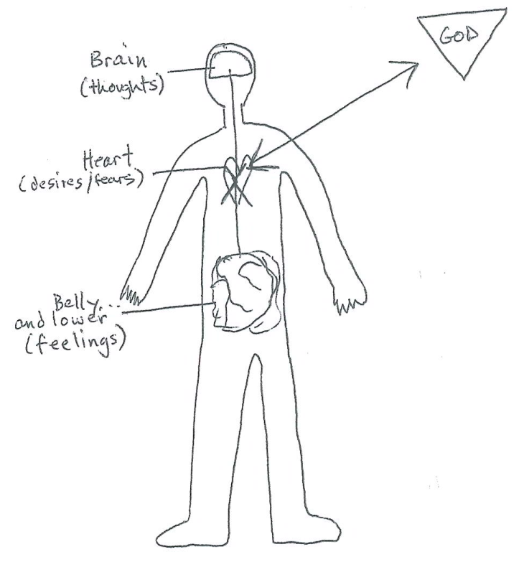
Encouragements for Prayer
- Builds a relationship with God
- Builds your identity
- Beloved son/daughter of God the Father
- Brother/Sister of Jesus, the Son
- Develops and strengthens your Mission

How do we have a relationship?
- Speaking
- Listening

“Pray like a pirate”
- Acknowledge any thoughts, feelings, desires, fears
- Relate them to the Father, the Son, the Spirit, Mary, etc.
- Receive a reply, often a sense of peace, joy, holy presence
- Respond with gratitude and with action if necessary
“The most fruitful human activity
is to be able to receive God.”
-Fr. Jean Corbon
“Our best conversations happen in silent intimacy,
with NO distractions, when our heart speaks to
the other’s heart.”
How to Develop a Prayer Life in 5 Easy Steps
- Aim for daily prayer—at least 5 minutes
- In the silence of your heart, become aware of His Presence
- Speak—ask for a specific grace or desire you need to draw closer to Him
- Listen…follow what He speaks to you. It might be little things at first but abide to His commands
- Thank Him and decide how to move forward

Spirit Alive

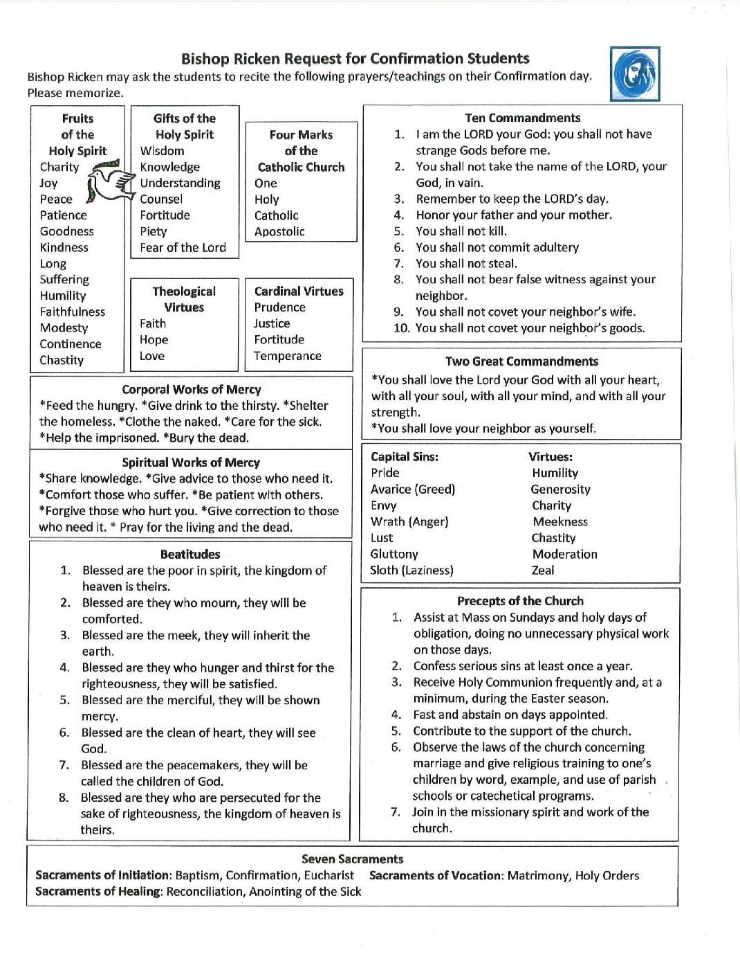

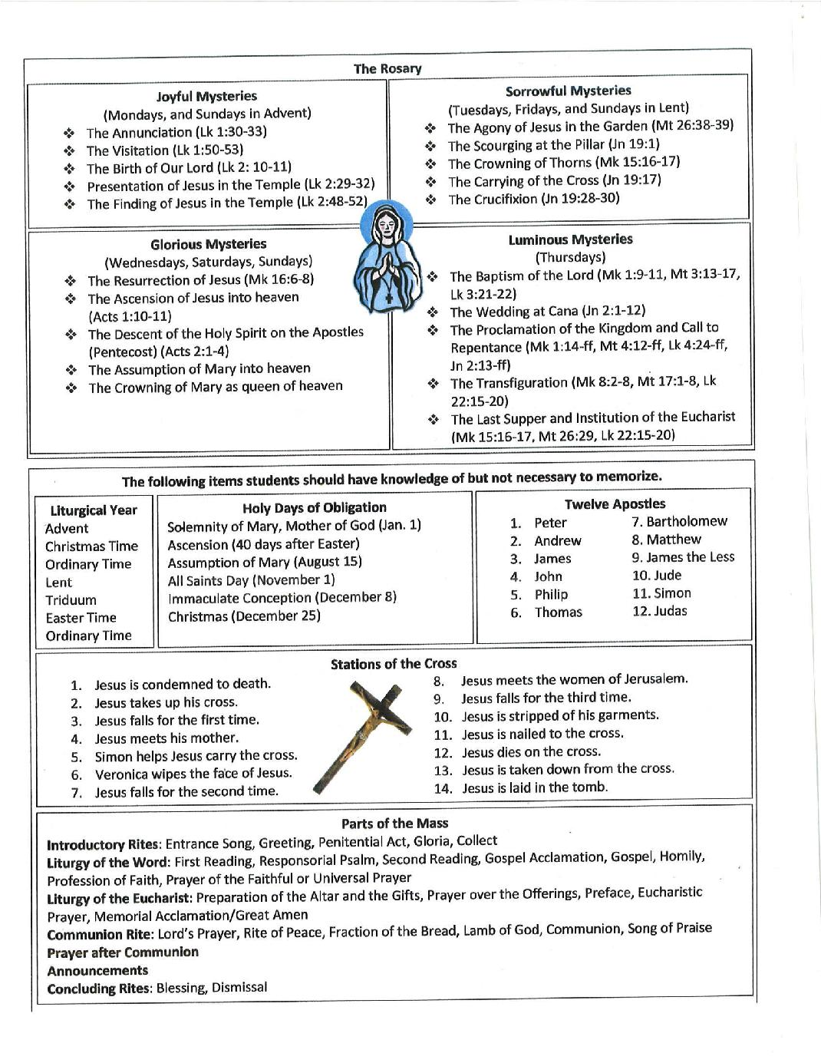

Spirit Alive
Class 2 – God’s Love & His Promises

The Old Testament sets the stage for the full expression of God's love in His Son Jesus. As we read and pray certain passages from the Old Testament, we can become more deeply aware of how much God does really love us. We need to know and experience God’s love if we are to develop into the people He wants us to be. This is especially important if we do not love ourselves as we should. Knowing our faults and failures and our sinfulness, we may question how God could really love us.

By praying with Sacred Scriptures we will become more aware and convinced of God’s total and unconditional love. This conviction that God loves us with an infinite love and that nothing we do will change this fact should be the foundation of our relationship with Him. We must come to know Him as a loving, kind, forgiving Father who welcomes His errant children with open arms. He is a Father who loves us more than we could ever imagine being loved. God, the Creator of the universe, the person who made all things out of nothing, loves us. He wants to care for us, share His divine life with us, and bring us into perfect union with Him, for all of eternity.

When we are convinced that we are loved, only then can we be open and honest. Then there is no need for pretense or shame. Then we will begin to live in freedom and in sincerity.

An awareness of God's great love for us can lead us into a greater depth in our prayer lives. Deeply aware of His loving presence we want to whisper in the quiet of our hearts, "I love You too." This type of prayer of the heart is the beginning of contemplative prayer. As we experience His loving presence within us, we no longer require words or thoughts. We simply rest in His presence. We are aware of God; we are known and loved at the very core of our being. This becomes the basis for our whole spiritual growth.

First, we know with our minds that God truly loves, but then we must become convinced in our hearts so that we can respond to His great love. This conviction will be ours when we hear God Himself telling us of His great love for us. Listen to His word in the Scripture readings each day.

 | Weekly Reading & Prayer Assignme | nts
Week | Scripture | Catechsim Rosary – Glorious Mysteries
Week 1 | Isaiah 43:1-3, | CCC 50 | 1. The Resurrection of
 | Psalm 139:1-6 | CCC 210 | the Lord
Week 2 | Ezekiel 34:11-16 | CCC 214
 | Isaiah 49:1-6 | CCC 218
Week 3 | Jeremiah 31:31-34 | CCC 220 | 2. Ascension of Jesus
 | 1 John 4:16-18 | CCC 221 | to Heaven
Week 4 | John 3:16-18 | CCC 609

Breaking Down the Faith
Class 2 - God’s Love & His Promises
Each lesson will have an extra section focusing on a couple different aspects of our faith that we will breakdown. A lot of times, we go through the motions with our faith—we say the same prayers, do the same activities—and we don’t even know what it really means. “Breaking Down the Faith” will expand on the Bishop’s Guide to Confirmation but will also focus on specifics popular items in our Church. Try to memorize or at least retain this information. You will also have a saint to focus on during this week.
The 2 Great Commandments ------------------------------------------------------
- You shall love the Lord your God with all your heart, with all your soul, with all your mind, and with all your strength. [Mark 12:30]

- You shall love your neighbor as yourself. [Mark 12:31]
Take some time to reflect on these 2 Commandments [memorize these]. Sit in silence for 5-10 minutes and ask yourself what these Commandments mean to you. Relax and center yourself in prayer then reflect on the following questions. As your journaling assignment, choose 1 question to expand on and write a response.
-What is your relationship like with God? Can you say that you actually love the Lord with all your heart, soul, mind, and strength?

-God created you in HIS image. In order to love others, you must love yourself. What does this mean to you? Does anything hold you back from loving others?
The Beatitudes -----------------------------------------------------------------------------The Beatitudes, by definition, are known as “exalted happiness.” They are often looked at as a supplement to the 10 Commandments and expand upon the Commandments to give us clear direction as to how to live out our faith. The Beatitudes come from Jesus’s “Sermon on the Mount” [Matthew 5:3-11].
Blessed are...
....the poor in spirit: for theirs is the kingdom of Heaven. (Matt 5:3)
....those who mourn: for they will be comforted. (Matt 5:4)
....the meek: for they will inherit the earth. (Matt 5:5)
....those who hunger and thirst for righteousness: for they will be filled. (Matt 5:6)
....the merciful: for they will be shown mercy. (Matt 5:7)
....the pure in heart: for they will see God. (Matt 5:8)
....the peacemakers: for they will be called children of God. (Matt 5:9)
....those who are persecuted for righteousness' sake: for theirs is the kingdom of heaven. (Matt 5:10)

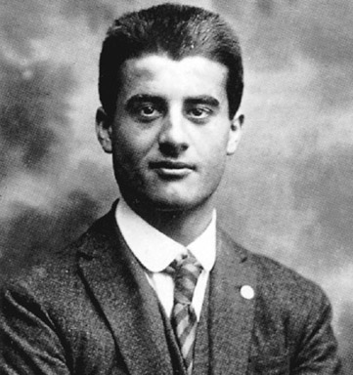
Bl.Pier Giorgio Frassati is on his way to becoming a saint in our Church. He is known as the “Man of Beatitudes” because he lived them out in his own life. Coming from a wealthy family, Pier Giorgio knew he was called to serve. He went out and ministered to the sick, the poor, and the needy. He also would play poker with his friends he’d bet if they lost that they would have to go to Mass with him. He ended
up dying in his 20’s from tuberculosis which he contracted from ministering to the sick in his area .
Spirit Alive
Class 3 – Salvation

In the first seminar we focused on God's love for us. The second seminar will also be about God's love, but with a different viewpoint - we will now look at our response, our acceptance of that love.

The Fourth Eucharistic Prayer that we pray at Mass captures the scope of God’s plan:

Even when (man) disobeyed you and lost your friendship, you did not abandon him to the power of death, but helped man seek and find you. Again and again you offered a covenant to man, and through the prophets taught him to hope for salvation. Father, you so loved the world that in the fullness of time you sent your only Son to be our Savior.

By dying on the cross, Jesus became our Savior and offers us the gift of salvation. It is ours to accept or reject. He does not force anything on us.

The question is often asked: “Have you been saved?” implying, “Are you going to heaven?” The answer is not found in a simple one-time commitment or acknowledgment of Jesus as Lord and Savior. From a Catholic perspective the answer is, “Yes, many times,” since salvation is not just for the future. We tap into God’s salvation and are saved from the effect of original sin at Baptism. We are saved again and again from the power of sin in our lives through repentance and ongoing conversion. And finally, those who “endure to the end” (Revelation 2:26) will be saved eternally from the presence of sin in heaven.

As good as salvation is, some people stand at the threshold and hesitate. Some feel unworthy of such love as they begin to contemplate the fact that God, the Creator of the universe, gave His only Son's life so that we may have eternal life. Others are still too strongly attached to the temporary pleasures of the world we live in. God is calling all of us to trust, to be reconciled with Him, to repent with honest and sincere hearts so that we can receive His gift of salvation. There is no love here on earth that can compare, so let us not look for a human comprehension or understanding of love that we have known. Always look instead to God.

 | Weekly Reading Assignments
Date | Scripture | Catechism Rosary – Glorious Mysteries
Week 1 | Micah 4:1-6 | CCC 54 3. Descent of the Holy
 | Isaiah 55:9 | CCC 122 Spirit at Pentecost
Week 2 | Psalm 45:1-9 | CCC 207 4. The Assumption of
 | John 11:21-27 | CCC 55 Mary into Heaven
Week 3 | Romans 5:6-8 | CCC 604 5. The Crowning of Mary as
 | Isaiah 53:4-6 | CCC 1505 Queen of Heaven & Earth
Week 4 | Colossians 1:13-14 | CCC 517

Breaking Down the Faith
Class 3 - Salvation
Each lesson will have an extra section focusing on a couple different aspects of our faith that we will breakdown. A lot of times, we go through the motions with our faith—we say the same prayers, do the same activities—and we don’t even know what it really means. “Breaking Down the Faith” will expand on the Bishop’s Guide to Confirmation but will also focus on specifics popular items in our Church. Try to memorize or at least retain this information. You will also have a saint to focus on during this week.
Salvation History ----------------------------------------------------------------------------
1. Creation
- Before the Fall: perfect harmony with God. Nothing evil existed.
- Fall: evil entered the world, our relationship with God was broken and we could no longer hear him like we once did.
- After the Fall: God attempts to reconnect us with him in many ways, but none of them worked because humankind was so fallen…until Jesus.
2. After the Fall: attempted redemption through prophets, covenants, and laws
- Prophets: people God chose to speak through to send His message
- Covenants: beloved promises God made to people to re-connect after the fall
- Laws: Truth that if the people followed, would allow them to be re-connected with God
  - 10 Commandments [see Bishop’s Guide for full list-memorize these]
3. God becomes man—Jesus— don’t forget that without the Blessed Virgin Mary, we wouldn’t have Jesus
- Takes on humanness to have validity as God and in his redemption. But most importantly, God wanted to become man so he could dwell with his creation, his people. The personhood of Jesus is a mystery because he was 100% man AND 100% God. He had every aspect of humanity that we have—he shared in our sorrows, happiness, joys, and anger BUT because he was God, he didn’t suffer from the fallen nature of sin. He was tempted, but never fell into sin.
4. Jesus’s death & resurrection
- Jesus does something LIFE changing that has never happened in the history of the world. He dies, but doesn’t stay dead. He is resurrected from the dead to prove that he is truly God. Before his death, Heaven or hell didn’t exist—those who died before Jesus, simply went to the “Bosom of Abraham,” a resting place. They didn’t get to experience God in Heaven. Jesus took on the sins of the world becoming the ultimate sacrifice of love and his cross acted as our bridge to Heaven. When Jesus died, he established a Heaven, a hell, and a purgatory. He became the NEW ADAM by redeeming all of mankind.
- Beatific Vision: one day, we will be in Heaven if we have faith and follow His commandments
- Sacraments: 7 Sacraments given to us so that we can receive God’s grace and so that he can give us a little piece of Himself in every Sacrament.
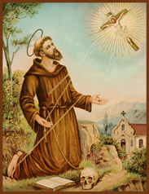
  - Baptism, Eucharist, Reconciliation, Anointing of the Sick, Confirmation, Holy Orders, Holy Matrimony [memorize these]
St. Francis of Assisi abandoned a life of luxury for a life devoted to Christianity after reportedly hearing the voice of God, who commanded him to rebuild the Christian church and live in poverty. He is the patron saint for ecologists, often depicted with a wolf.

Spirit Alive
Class 4 – Preview of New Life in the Spirit

Throughout the ages, prophets predicted the day would come when God would give His Spirit freely to men. Those who turned to Him and received His Spirit would be changed. They would receive new life. We remember this event in the third glorious mystery of the Rosary, “The Descent of the Holy Spirit.”

Jesus' promise to fulfill that prediction happened on Pentecost when the disciples were gathered together in prayer and the Holy Spirit appeared in the form of tongues of fire. They began to prophesy and heal the sick; they prayed in tongues and proclaimed the Good News boldly. And thousands of Jews became believers in Jesus Christ as the Son of God.

We received the same Holy Spirit in our Baptism and His presence in us was strengthened in Confirmation. For many of us, however, the fullness of the Holy Spirit's action in our lives is still awaiting our invitation.

We can experience the Holy Spirit in the same way the first disciples did. And when the Holy Spirit is released more fully in us, we will begin to experience a new kind of life. We get to know God in a new way and we become changed people. Then, as we continue to grow in faith, we want to reach out and serve others. God equips us with the spiritual gifts we need to do His work.

Jesus told us, "I have come that you may have life and have it in abundance" (John 10:10). This abundant life is not only a promise of spending eternity with God in heaven but a new life here and now. We receive it by yielding to God to have Him more active in our lives.

Our daily readings this week will reveal the extent of this promise.

 | Weekly Reading Assignments
Date | Scripture | Catechism Rosary – Luminous Mysteries
Week 1 | Ezekiel 36:22-28 | CCC 1287 1. The Baptism of our
 | John 14:15-18 | CCC 729 Lord
Week 2 | Acts 2:1-14 | CCC 696 2. Wedding Feast at Cana
 | Acts 19:5-7 | CCC 1288
Week 3 | Galatians 5:16-23 | CCC 736 3. Proclamation of the
 | 1 Corinth 12:4-11 | CCC 801 Kingdom of Heaven
Week 4 | Ephesians 2:19-22 | CCC 756

Breaking Down the Faith
Class 4 – Preview of the New Life in the Spirit
Each lesson will have an extra section focusing on a couple different aspects of our faith that we will breakdown. A lot of times, we go through the motions with our faith—we say the same prayers, do the same activities—and we don’t even know what it really means. “Breaking Down the Faith” will expand on the Bishop’s Guide to Confirmation but will also focus on specifics popular items in our Church. Try to memorize or at least retain this information. You will also have a saint to focus on during this week.
Story of Pentecost -------------------------------------------------------------------------
In your Bible: Acts 2:1-13

When the time for Pentecost was fulfilled, they were all in one place together, and suddenly there came from the sky a noise like a strong driving wind, and it filled the entire house in which they were. Then there appeared to them tongues as of fire, which parted and came to rest on each one of them. And they were all filled with the holy Spirit and began to speak in different tongues, as the Spirit enabled them to proclaim.
Now there were devout Jews from every nation under heaven staying in Jerusalem. At this sound, they gathered in a large crowd, but they were confused because each one heard them speaking in his own language. They were astounded, and in amazement they asked, “Are not all these people who are speaking Galileans? Then how does each of us hear them in his own native language? We are Parthians, Medes, and Elamites, inhabitants of Mesopotamia, Judea and Cappadocia, Pontus and Asia, Phrygia and Pamphylia, Egypt and the districts of Libya near Cyrene, as well as travelers from Rome, both Jews and converts to Judaism, Cretans and Arabs, yet we hear them speaking in our own tongues of the mighty acts of God.”
They were all astounded and bewildered, and said to one another, “What does this mean?”

7 Gifts of the Holy Spirit ------------------------------------------------------------------
1. Wisdom 2. Understanding 3. Counsel 4. Courage 5. Knowledge 6. Piety 7. Fear of the Lord [memorize these]
Wisdom: See things the way God would. Understanding: allows us to grasp the Truths of the faith.
Counsel: Figuring out the best decision, judgment, guidance. Courage: Supernatural strength.
Knowledge: Gives us the ability to judge what is right and wrong. Piety: perfection of religion, the desire to pray and get closer to God. Fear of the Lord: to praise God, to be in wonder and awe.

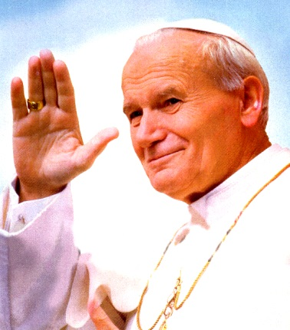
St. Pope John Paul the Great is recognized as helping to end Communist rule in his native Poland and eventually all of Europe. He significantly improved the Catholic Church's relations with Judaism, Islam, the Eastern Orthodox Church, and the Anglican Communion. He upheld the Church's teachings on such matters as artificial contraception & the ordination of women, but also supported the Church's 2nd Vatican Council & its reforms. He was one of the most travelled world leaders in history, visiting 129 countries during his pontificate. As part of his special emphasis on the universal call to holiness, he beatified 1,340 people & canonized 483 saints.

Spirit Alive
Class 5 – Receiving God’s Gift

The topics covered thus far have been about God’s love, salvation, and new life. These became more personalized through the sharing of personal experiences by the speakers. This has been a time of preparation, and, through prayer, you may also have begun to experience a new closeness to God.

The next step is yours. Living a committed Christian life and putting our Catholic faith into action affects everything we do. We cannot straddle the fence; there is no room for being lukewarm (see Revelation 3:16).

John the Baptist, the prophet who prepared the way of the Lord, preached one basic message, “Repent, for the kingdom of God is at hand” (Matthew 3:2). Throughout the New Testament, the need for repentance and forgiveness is preached. Repentance was the path, which prepared the way for the coming of the Lord, and Jesus is calling us to repentance as we prepare our lives for His coming to us in a deeper way.

Repentance involves sorrow for our sins, turning toward God, and reorienting our lives. It involves a fundamental change of attitude, a conversion of heart towards God and away from sin. In addition, we are told, “Declare your sins to one another, that you may find healing” (James 5:16). For Catholics, the Sacrament of Reconciliation is the way we live out this command. We are invited by God to receive His gift of forgiveness for any sins through the Sacrament, but confession of serious sins to a priest is necessary before Catholics can partake of other Sacraments, particularly the Holy Eucharist. It is also recommended as a first step when making a deeper commitment to our Lord.

Repentance requires honesty with ourselves. Many times “pet” sins have become a part of our lives, and we have learned to rationalize away their sinfulness. Perhaps you have a habit of gossip, or drinking too much, or some form of impurity. Maybe it is being judgmental or selfish. Whatever your personal weaknesses may be, it is impossible to repent until we call them sin and no longer make excuses like, “That’s just the way I am.”

 | Weekly Reading Assignments
Date | Scripture | Catechism Rosary - Luminous
Week 1 | Psalm 51 | CCC 1850 4. The Transfiguration
 | Isaiah 1:16-18 | CCC 1430, 1431 at Mount Tabor
Week 2 | 1 John 2:1-6 | CCC 1422, 1424
 | Psalm 32 | CCC 1502
Week 3 | 1 John 3:4-10 | CCC 385 5. The Last Supper/
 | John 20:20-23 | CCC 1447 Institution of the Eucharist
Week 4 | Hebrews 10:11-18 | CCC 1442
Breaking Down the Faith
Class 5 – Receiving God’s Gift
Each lesson will have an extra section focusing on a couple different aspects of our faith that we will breakdown. A lot of times, we go through the motions with our faith—we say the same prayers, do the same activities—and we don’t even know what it really means. “Breaking Down the Faith” will expand on the Bishop’s Guide to Confirmation but will also focus on specifics popular items in our Church. Try to memorize or at least retain this information. You will also have a saint to focus on during this week.
Cardinal Virtues ----------------------------------------------------------------------------
These are 4 principle moral virtues where all other aspects of morality hinge from. They are: prudence, justice, fortitude, and temperance. Prudence: having “right reason applied to practice.” It allows to judge what is right and wrong in any situation. Justice: giving everyone his/her rightful due. Fortitude: allows us to overcome fear and remain steady in our will in the face of obstacles. Temperance: restraint of our desires and passions—can also be viewed as moderation.
Capital Sins-source of all sin. There are 7 of them.
Pride, Greed, Envy, Wrath, Lust, Gluttony, Laziness (sloth)
Capital Virtues-source of grace.
Humility, Generosity, Charity, Meekness, Chastity, Moderation, Zeal

Blessed Mother & her Fiat---------------------------------------------------------------
Mary plays an important role in our faith and in humanity. She was chosen by God to carry Jesus Christ, the son of God, in her womb and to be His mother. She was born without sin—the only human being in history (minus Jesus) to experience this. She is literally PERFECT! What’s even more amazing about the Blessed Mother is that she became OUR mother at the foot of the Cross, when Jesus instructs John to take care of her. We look to her as being the ultimate hand-maid of the Lord. This “Fiat,” saying “yes” to the will of God marks her as the “New Eve,” who disobeyed God. It is particularly important for us as Catholics to recognize and honor Mary.
Luke 1:38 - Mary said, “Behold, I am the handmaid of the Lord. May it be done to me according to your word.” (This is Mary’s Fiat. May we be able to be as open to God’s will in our lives as Mary was in her’s).

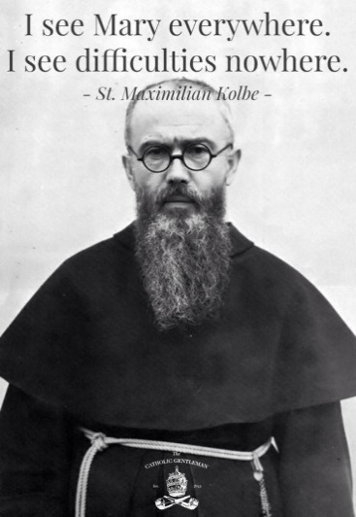
St. Maximilian Kolbe was a Polish Conventual Franciscan friar, who volunteered to die in place of a stranger in the German death camp of Auschwitz. He was active in promoting the veneration of the Immaculate Virgin Mary, founding and supervising the monastery near Warsaw, operating a radio station, and founding or running several other organizations and publications. Kolbe was canonized on 10 October 1982 by Pope John Paul II, and declared a martyr of charity. He is the patron saint of drug addicts, political prisoners, families, journalists, prisoners, and the pro-life movement. John Paul II declared him "The Patron Saint of Our Difficult Century".

Spirit Alive
Class 6 – Release of the Holy Spirit

Next week, after our opening time of praise and a brief teaching, prayer teams will be available to pray with you for the release of the Holy Spirit, commonly referred to as ‘baptism in the Holy Spirit.’ This release of the Spirit is an internal religious experience (or prayer experience) in which Christ is experienced in a personal way. It involves openness to the power of the Holy Spirit whom we received in Baptism and Confirmation, and this empowerment usually leads to a deeper devotional life and an attraction to prayer, Sacred Scripture, and the Sacraments of the Church. With continued nurturing, this event will be the beginning of a lifelong process of growing closer to God.

As you prepare for this important event in your spiritual life, keep in mind that what happens to others may or may not be the same thing that happens to you. Pray to be completely open to the love that God wants to express personally to you next week and in the days, weeks, months and years ahead. This is only the beginning of a life long journey with Jesus.

Be open to receiving all of the gifts of the Holy Spirit that the Lord wants to give you (see 1 Corinthians 12:1-11). When you are prayed for, a word may seem to come “out of nowhere” or a Scripture passage may come strongly to mind. This is the Lord speaking. As you pray, you may “run out of words” and sense strange sounds wanting to come from your lips. Verbalize them; the Lord may be giving you the gift of tongues to praise Him. It is a heavenly language but if you feel nothing, that is okay too. God is still moving within you.

During the coming week, you may experience feelings of unworthiness, or you may feel reluctant or apprehensive because it seems that what you are doing is strange or unnecessary. These are fairly common reactions at this place in the Catholic Faith in Action Seminar, but recall God's call to you and focus on that. Review your journal and see how he has been preparing you for this event.

Finally, be assured of the prayer support, which is being offered to our Father for you this week. If you are concerned about anything or if you have any questions, call your group leader or any one of the team members. Do not let doubt or Satan keep you from receiving answers to questions and the assurance Jesus wants you to have. Sometimes we can rationalize away what God wants to do.
 | Weekly Reading Assignments
Date | Scripture |  | Catechism Rosary - Sorrowful Mysteries
Week 1 | Matthew 18:1-4 |  | CCC 576 1. The Agony in the
 | Acts 2:33-36 |  | CCC 731 Garden
Week 2 | 2 | Corinthians 12:1-10 | CCC 273
 | Luke 6:27-36 |  | CCC 2842
Week 3 | Matthew 11:25-30 |  | CCC 2603 2. The Scourging at the
 | 2 | Corinthians 6:14-18 | CCC 1179 Pillar
Week 4 | 2 | Corinthians 4:1-6 | CCC 298

Breaking Down the Faith
Class 6 – Release of the Holy Spirit
Each lesson will have an extra section focusing on a couple different aspects of our faith that we will breakdown. A lot of times, we go through the motions with our faith—we say the same prayers, do the same activities—and we don’t even know what it really means. “Breaking Down the Faith” will expand on the Bishop’s Guide to Confirmation but will also focus on specifics popular items in our Church. Try to memorize or at least retain this information. You will also have a saint to focus on during this week.
Charismatic Gifts -------------------------------------------------------------------------
Charism means “grace, talent from God. Spiritual gift, divine grace.” Charismatic gifts are gifts of the Spirit—just like the 7 ones received in Baptism, but these charismatic gifts can be classified into different categories (taken from 1 Corinthians, Chapter 14):
- Charisms of the Mind: (vocal and interior)
1. The word of wisdom - Allows us to think as God would think. This gift is a vocalized gift
meaning it’s to be shared with others.
2. The word of knowledge - God gives a person a specific knowledge about a person or situation
that could not be known otherwise, unless God revealed it. Another gift that should be
shared with others.
3. The discernment of spirits - This is an important gift to distinguish the good and bad spirits,
the true and false prophets.*The gift of wisdom is completely necessary for this gift.

- Charisms of Action: (physical)
1. The gift of healing - There are many ways God bestows the gifts of healing: by the laying on of
hands, by anointing, or with sacramental objects or by just praying.
2. The working of miracles - This gift is different from healing in that it does not depend on the
laws of nature. It is “a wonder” of God when miracles happen.
3. The gift of faith - It is probably the most important charism of the gifts of action: The gift of
Faith is kind of power that can move mountains.

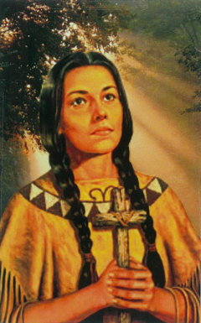
- Charisms of the Tongue: (physical)
1. Prophecy - This is a gift by which God, through a person, speaks a message to an individual or
to the whole Christian community. A prophet speaks to people about God or from God.
2. Speaking in tongues - The person is able to speak a new language of praise to God or
repentance, even though the individual does not understand what is being said. It is the
Spirit of God within the heart praying.
3. Interpretation of tongues - not a translation of what the other said, but an interpretation.
St. Kateri Tekakwitha known as the “Lily of the Mohawks.” Kateri was born near the town of Auriesville, New York, in the year 1656, the daughter of a Mohawk warrior. She was four years old when her mother died of smallpox. The disease also attacked Kateri and transfigured her face. Kateri became converted as a teenager. She was baptized at the age of twenty and incurred the great hostility of her tribe. Although she had to suffer greatly for her Faith, she remained firm in it. Kateri went to the new Christian colony of Indians in Canada. Here she lived a life dedicated to prayer, penitential practices, and care for the sick and aged. She was the 1st Native American to be canonized as a saint.

Spirit Alive
Class 7 – Growth Through Ongoing Conversion
To some extent we all have a limited view of God. We confine His actions in our lives to what we think and expect Him to do. But as we grow in our relationship with Him, we recognize more completely who He really is. We recognize His role in life’s “coincidences” and in the goodness that flows from people who are close to him. Growth in love is always a manifestation of the Holy Spirit within us, working through us and upon us.

This new life in the Spirit is not something to be experienced only at prayer meetings, or in a church on Sunday, or in our prayer closet, or alone by ourselves. This new life means just that, a changed life, a new person, different from what we used to be. And this change is a growing experience, a daily walk (and struggle) in a new life.

Nourishment is a necessity for growth. As we strive to put our Catholic faith into action, daily prayer will be a must. Scripture reading and meditation is a must. Listening to God is a must. Through our devotion and meditation, through self-discipline and the encouragement of others, the Father will direct our continued life-in-the-Spirit.

As Catholics we can anticipate a deeper devotion and love for the Eucharist and commitment to Eucharistic Adoration. Our lives will revolve around Jesus and the Mass. A hunger for scriptural understanding and spiritual reading will be aroused. Satisfy this hunger by reading. Follow these inclinations and desires of your heart. Do not stifle these quiet inner suggestions by thinking they are ridiculous or by putting them aside. As you continue to grow, there will be times when you feel the intensity of God's love. Bask in God’s love and enjoy it, for there will also be days when your spiritual life seems dry, and God seems distant. These dry desert times provide a different kind of opportunity for continued growth, provided you maintain your devotion to daily prayer, scripture reading and listening to God. Growing in Christ is similar to growing like a child. There are times when you will jump, run, skip, laugh, and delight in your relationship with Jesus. There will also be times when you stumble, slip, and skin your knee when you fail to listen or disobey.
Our Lord is love. He is always there ready to pick us up and to address all our feelings and all our needs, but we must give Him the freedom to move.

 | Weekly Reading Assignments
Date | Scripture | Catechism Rosary - Sorrowful Mysteries
Week 1 | Philippians 1:18-19 | CCC 2697 3. Crowning with Thorns
 | Philippians 2:1-11 | CCC 1694
Week 2 | Philippians 2:12-18 | CCC 1070 4. Carrying of the Cross
 | 1 Peter 4:7-19 | CCC 1434
Week 3 | 2 Timothy 4:1-5 | CCC 2015 5. The Crucifixion &
 | Romans 6:1-11 | CCC 1694 Death of our Lord
Week 4 | John 15:1-8 | CCC 787
Breaking Down the Faith
Class 7 – Growth Through On-Going Conversion
Each lesson will have an extra section focusing on a couple different aspects of our faith that we will breakdown. A lot of times, we go through the motions with our faith—we say the same prayers, do the same activities—and we don’t even know what it really means. “Breaking Down the Faith” will expand on the Bishop’s Guide to Confirmation but will also focus on specifics popular items in our Church. Try to memorize or at least retain this information. You will also have a saint to focus on during this week.
4 Marks of the Church [memorize these] -------------------------------------------------
- ONE
Just as God is one in the Father, Son, and Holy Spirit, so also is the Church one.
- APOSTOLIC
The Church traces its tradition directly from the apostles. The Holy Spirit has guided the Church
- CATHOLIC
“Catholic” means universal. The Church is universal by baptism and the Church’s mission .
- HOLY
The Church is holy because the Church lives in union with Jesus Christ, the source of holiness.

Precepts of the Church [memorize these] -------------------------------------------------
- Assist—attend and participate—at Mass on Sundays and Holy Days of Obligation, doing no unnecessary physical work.
- Confess serious—mortal—sin at least once a year.
- Receive Holy Communion frequently, and at minimum, during the Easter season—you still need to go to Mass, but need to be free of mortal sin in order to receive the Eucharist.
- Fast and abstain on appointed days. If you do not know these days, please see the list
- Contribute to the support of the church—financially or in other ways—if you are good at singing, give back to the church by using your gift in the choir. We are always looking for more ushers to help at Mass.
- Observe the laws of the church concerning marriage and give religious training to children by word, example, use of parish schools or catechetical programs.
- Join the missionary spirit and work of the church. Continue signing up for Service Saturdays, attend a summer trip through our youth group, sign up to teach a religion class on Wednesday nights. Just because you get confirmed doesn’t mean you’re done with your duty as a missionary.

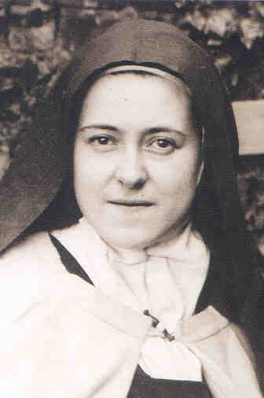
St. Therese of Lisieux died at the young age of 24 but contributed so much to the Church that she became a Doctor of the Church. She is known as the “Little Flower” due to the simplicity of the way she lived out her faith. She loved people in the “little way.” Even though she desired to travel and be a missionary, she felt called to the reclusive life of the Carmelites and devoted her life to deep prayer and penance. She suffered immensely from tuberculosis which ended up taking her life. She wrote tirelessly in order to express her deep love for Jesus and the Church.

Spirit Alive
Class 8 – Transformation in Christ

As we move into the final week of the Catholic Faith in Action Seminar, the transformation of our lives is just beginning. Our true identity as Catholic Christians continues to mature; in the weeks to come, the Holy Spirit will become increasingly visible in our lives - visible to ourselves and to others. The Holy Spirit is at work, transforming us, and making us holy. But that’s not all.

It is common to experience a joyful honeymoon time with God in the weeks following the release of the Holy Spirit. In time, however, we recognize that the Catholic Faith in Action is not just a God and me kind of relationship. The gifts we have received are not just for us and our personal growth; the Holy Spirit is also encouraging us to share our “new life” with others. The focus moves away from me and toward others. As Pope Paul VI said, “The Church exists to evangelize.”

But not only do others need us, we also need them. God has given us the gifts of the Holy Spirit (charisms) to steer us and to make us more effective in carrying out our mission in life. Although the dramatic gifts like healing and prophecy can attract a lot of attention, we need to learn about and recognize all of the gifts God is giving so that we can allow them to unfold. Our faith community provides a very helpful environment for the discernment and development of our gifts.

Each of us belongs to various communities: our individual families, our neighborhood, our parish, our business associations, our friends, our prayer group, our Bible study group, etc. They are all important, but the role of a "gift-sharing” community with similar experiences of the Holy Spirit will be especially helpful in nurturing the new relationship we have established with God. Our faith community has another but often overlooked branch - the Saints in heaven. It can be very beneficial to study their lives and allow them to become our models. We can also ask for their intercession.

Finally, as we conclude the seminar, we need to be aware that baptism in the Holy Spirit is not an inoculation against trials and difficulties. We are still human beings living in a sinful world. There will be challenges to our faith. But we now have a new power to overcome these difficulties and a prayer community to provide strength and encouragement.

 | Weekly Reading Assignments
Date | Scripture | Catechism Rosary – Joyful Mysteries
Week 1 | 1 Peter 1:22-25 | CCC 2767 1. The Annunciation
 | James 1:14-26 | CCC 2847
Week 2 | James 5:7-12 | CCC 736 2. The Visitation
 | Hebrews 13:1-9 | CCC 2447
Week 3 | Galatians 5:13-26 | CCC 2515 3. The Birth of Jesus
 | Galatians 6:1-10 | CCC 2030 4. The Presentation of Jesus
Week 4 | Ephesians 4:25-32 | CCC 2444 5. The Finding of Jesus in the  CCC 2842 Temple

Breaking Down the Faith
Class 8 – Transformation in Christ
Each lesson will have an extra section focusing on a couple different aspects of our faith that we will breakdown. A lot of times, we go through the motions with our faith—we say the same prayers, do the same activities—and we don’t even know what it really means. “Breaking Down the Faith” will expand on the Bishop’s Guide to Confirmation but will also focus on specifics popular items in our Church. Try to memorize or at least retain this information. You will also have a saint to focus on during this week.
Evangelization ---------------------------------------------------------------------------------
It is the mission of every Catholic to spread the Good News that Jesus Christ came to earth and died for our sins and resurrected so that one day, we can be reunited with God in Heaven. This is evangelization. It is our mission to enlighten others with the Good News.

We use the gifts of the Spirit, given to us at Baptism and sealed in Confirmation to bring the faith to others. It isn’t just up to priests and religious people to spread the Good News, but it’s up to YOU.

Works of Mercy -------------------------------------------------------------------------------
These are actions and practices which Christianity, in general, expects all believers to perform. The practice is commonly attributed to the Roman Catholic Church as an act of both penance and charity. There are 2 specific types:

- Corporeal – comes from the word “corpus” meaning “body.” These works of mercy focus on meeting the physical needs of people: feeding the hungry, clothing the naked, shelter the homeless, give drink to the thirsty, care for the sick, help the imprisoned, bury the dead. [memorize these]
- Spiritual - These works of mercy focus on meeting the spiritual needs of people: share knowledge, give advice to those who need it, comfort those who suffer, be patient with others, forgive those who hurt you, give correction for those who need it, pray for the living and the dead. [memorize these]

Bl. Chiara “Luce” Badano is in the process of becoming a saint in the Church. She died at the age of 19 from a debilitating form of bone cancer. Her nickname “Luce” means “light,” and she was truly a light for many people. She grew up in a small town in Italy where she did normal teenage things—she loved music, tennis, but she was always seen with a smile on her face. She died in 1990 and was asked to be buried in a wedding dress. Her last breath was taken in along with the words, “Come Holy Spirit.”

Appendix A
Practical Ways to Live Out your Confirmation

With Family and Friends:

- Show the love you have for God in word and action. If you have difficult relationships, pray for guidance on how to handle things and trust the Holy Spirit to show you what to say and/or do.

- Forgive someone who has wronged you. Ask for forgiveness from someone you have wronged. Try to keep doors open in these important relationships.

- Be open to share your personal faith story of how God has worked in your life when the opportunity arises. Ask the Holy Spirit to bring you circumstances where “the time is right” to tell your story. If you feel shy or uncomfortable, practice what you might say.

- Invite others to join you for Mass, a parish activity, or attending prayer group without indicating a sense of judging where they are spiritually.

- “Preach the gospel at all times – if necessary, use words.” Be an example on how a believer in Jesus Christ acts and speaks. Actually live out your faith. Don’t be afraid to say “no” to the things of this world

At Mass:

- Be friendly and move to the center of the church pew because that is an occasion for others to join you and offers an opening to meet those you do not know.

- Smile and share the love of God in you with others especially during the Sign of Peace.

- Pray for opportunities to share your story of faith with others.

In the Parish:

- Serve your parish as an usher, a Eucharistic minister, lector, choir member, whatever area you sense God is leading you in.

- Invite someone to attend youth group events and go with them.
(you can stay updated on youth group events by joining our Facebook Group: St. Bernard Youth Ministry)

- Become a catechist or small group leader to have the opportunity to share your faith.

In the Diocese:

- Attend annual youth conferences, summer trips, and Steubenville conference.

Appendix B
Becoming a New Creation: Why We Choose Confirmation Saints
Confirmation candidates are required to choose a Confirmation Name. This name symbolizes the completion of their Baptism through Confirmation where they are called to be a NEW CREATION in Christ and through the Holy Spirit. In the Bible and the Early Church, a new name represented a new phase in one's life with a great devotion to God.

- Abram became Abraham (Genesis 17:5)
- Jacob became Israel (Genesis 35:10)
- Simon became Peter (Matthew 16:17-18)
- Saul became Paul (Acts 13:9).
Candidates may choose to use their Baptismal (first) name, or they may choose the name of the saint they wish to adopt as their patron (role model). The saint chosen is often one the candidate admires or has a devotion to and should be of the same gender as the candidate.
How to Choose a Saint’s Name
During the Catholic sacrament of Confirmation, God the Holy Spirit comes upon you to bestow numerous spiritual gifts and "confirm" the faith given you in Baptism when Original Sin was wiped away. You choose a Confirmation name before Confirmation. This new name, imposed by the Bishop during Confirmation, becomes a part of your full name. It comes after your first and middle names and before the last name.

- Find a list of canonized saints in the Roman Catholic Church by reading a book or doing online research. Saints are people who have lived holy lives and are now in heaven as members of the Church Triumphant. Their life stories provide examples for others on how to overcome spiritual obstacles on Earth.
- Read about male saints if you're male and female saints if you're female. Generally speaking, you'll want to choose a name that matches your gender.
- Pray to the Holy Spirit, and ask Him for help in finding a saint whose life you'd like to imitate. This saint will be bonded with you spiritually, and in essence becomes your heavenly patron who intercedes for you before God.
- Narrow your selection to two saints. One of them will be your new Confirmation name. Think about the specific virtues those saints exhibited, such as patience, perfection, diligence, humility, mortification, meekness, obedience, prayer, charity or simplicity. Find a virtue that connects with you.
- Consider the one or two special stories told about those saints on your "short" list to help you find a spiritual connection. For example, St. Maximilian Kobe gave up his life for another person's life in a concentration camp during World War II, and so showed the virtue of selflessness. St. Francis, a spiritual leader who founded a religious order, led a simple life of poverty and greatly loved animals.
- Take your list of two saints to a family member or your sponsor who is a practicing Catholic. Talk about the saints' lives with that person, and discuss what attracts you spiritually to these holy people.
- Select your Confirmation name, and inform your family and friends. Get used to it by saying it over and over again in your mind. Practice writing it as part of your full name.
- Before you are confirmed, pray to the saint whose name you will be using as your Confirmation name. Ask this saint to intercede for you, to help you make the right moral choices, and overall to be a powerful spiritual guide the rest of your life. They have now become your patron saint.
- Buy pictures, holy cards, medals, statues and books associated with your Confirmation's namesake. These visual reminders of your saint will help you reflect upon his or her unique virtues.

