Seven Gifts of the Holy Spirit received at Confirmation
“the gifts enhance the power of the soul and make our hearts more sensitive to God”

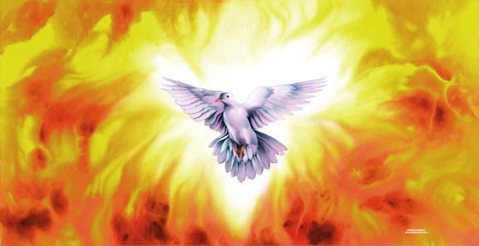
The gifts allow us to hear
and obey God better!

Wisdom
We see things from God’s perspective

Fear of the Lord
We have respect for God’s creation and glory. We are afraid of offending our Father.
Piety
Natural love for God and devotion. Obedience to God and his will.
Knowledge
We swiftly discern between the impulses of temptation (Devil) and the inspirations of grace (God)
Fortitude
Courage. Doing good despite obstacles.

Council
It allows us to judge quickly and correctly what should be done in difficult situations
Understanding
Our heart enters into truth even when it doesn’t fully comprehend its entire meaning.

