Created for Love

St. Raphael the Archangel

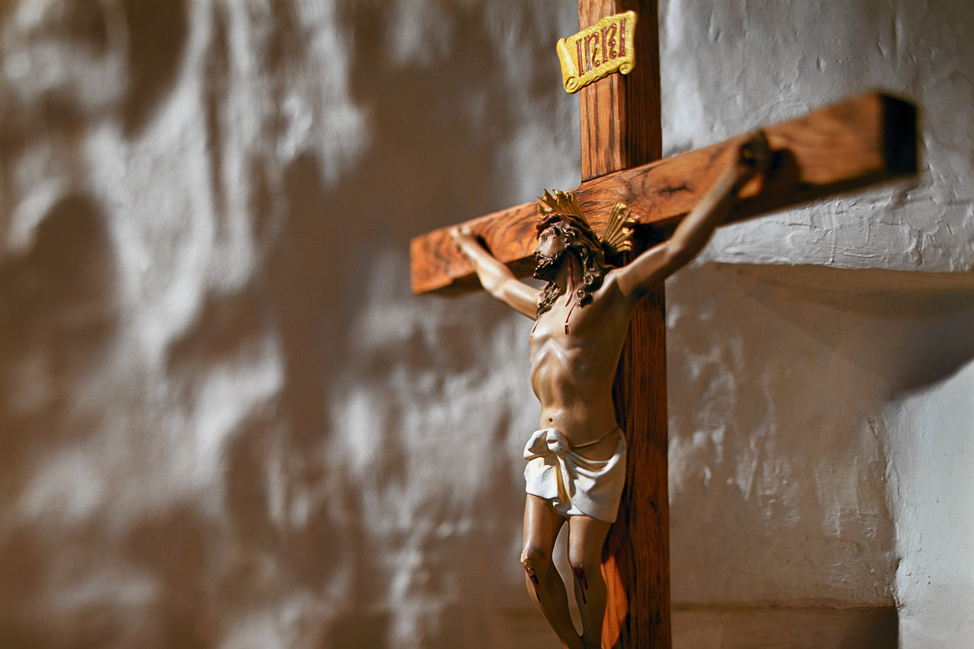

# The Body as Sacrament

To understand that our bodies are a sacrament we must first look at what does the word “sacrament” mean to us? God reveals himself to us through the sacraments. We cannot *see* God as pure spirit; God is totally beyond our vision. Yet Christians believe that the invisible God has made himself visible. How?

(CCC) In “the body of Jesus’ we see our God made visible and so are caught up in love of the God we cannot see”. (CCC 477)

God became a human, through Christ his whole fullness of deity (God) dwells bodily. St. Paul’s letter to the Colossians 2:9 “*for in him dwells the whole fullness of the deity bodily and you share in this fullness in him, who is the head of every principality and power.”*

What does it feel like to hear these words? “you share in this fullness in him” ____________________________________________________________________________________________________________________________________________________________

What are some ways in which God reveals his love for you in your life today? ____________________________________________________________________________________________________________________________________________________________________________________________________________________________________________________________________________________________________________________________________________________________________________________________________________________________________________________________________________________

C:\Users\tanya.hielke\AppData\Local\Microsoft\Windows\Temporary Internet Files\Content.IE5\OZEADT12\MC900413532[1].wmf**Genesis 1: 26-28, 31**  
*“Let us make man in our image, after our likeness. Let them have dominion over the fish of the sea, the birds of the air, and the cattle, and over all the wild animals and all the creatures that crawl on the ground.”  
God crated man in his image, in the divine image he created him; male and female he created them.  
God blessed them, saying: “Be fertile and multiply; fill the earth and subdue it.”  
God looked at everything he had made, and he found it very good.*

In Genesis God made us all in his image. And everything he made he found **very good**! So what is God saying about you?

_______________________________________________________________________________________________________________________________________

Our bodies were created by God for good and to be fruitful (one day) and multiply. He created us out of his pure love. You were made perfect in the eyes of God! What does it feel like to hear those words?

_____________________________________________

# *“Love consists of commitment which limits one’s freedom – it is a giving of the self, and to give oneself means just that: to limit one’s freedom on behalf of another.”*

# St. John Paul II, Love and Responsibility

# Who in your life do you make sacrifices for?

__________________________________________________________________________________________________________________________________________________________________

Who does God call us to make sacrifices for?

___________________________________________________________________________________________________________________________________________________

Who is making sacrifices for you?

______________________________________________________________________________________________________________________________________________________________________________________________________________________________________________________________________________________________________  
  
  
  
***St. John Paul II also said; “the opposite of love is not hate, the opposite of love is using.”***

God created us to be fruitful and multiply, he did not create us to use each other for our own pleasure or means to get something from another person.

Name a situation where you have used someone and didn’t realize it. (Parents, friends, teachers, boyfriend, girlfriend, siblings)

____________________________________________________________________________________________________________________________________________________________________________________________________

Using is not just sexual it could be using someone for their money, status, maybe to get a job you want or their skills to provide something for your needs.

Have you ever felt used? Think about that and reflect on ways we can be more aware of how God calls us to treat others.

God wants us to know that we are perfectly loved, and that we were made out of his perfect love for each of us. God does not want anyone to feel unloved. How can we protect ourselves from being used?

____________________________________________________________________________________________________________________________________________________________________________________________________

*“Spread love everywhere you go. Let no one ever come to you without leaving happier.” – Mother Teresa*

**What is chaste love?**

Chaste love (or living in chastity) is a love that defends itself against all the internal and external forces that might destroy it. Name some things that could destroy love:

____________________________________________________________________________________________________________________________________________________________________________________________________

How do I live a chaste life? Does it mean no sex?

To live a chaste life is to live deliberately motivated by love. Remember what love is defined as? *Willing the good of the other..* This includes our sexuality. Married people also are called to a chaste life.

Read: YOUCAT #404 and #405

In what relationships are you living a chaste life?

__________________________________________________________________________________________________

Are there any relationships where you are not living a chaste life?