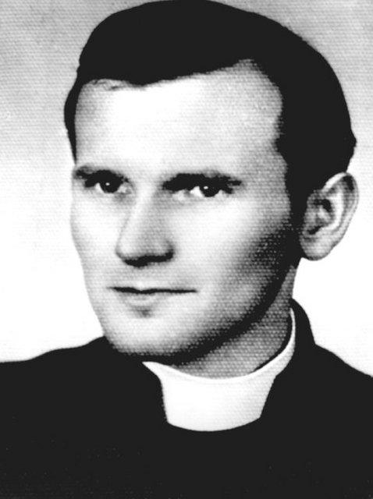
Theology of the Body – A Way of Life

The question then is this, how effective is catechesis if this personal encounter has not been the experience of our students, if the mystic inside them has not been activated, so to speak. The relationship between youth ministry and catechesis is this: youth ministry creates the environment for transformation (this encounter with God) so that formation can take place.

We incarnate the love of God. We reach out to youth in order to build relationships with them making the love of God more tangible. Fr. Wojtyla understood this for it was his experience as a youth with Jan Tyranowski. In Fr. Wojtyla’s first parish he organized a Living Rosary group. He was then made chaplain at St. Florian’s parish in Krakow. It was here that he formed deep personal, spiritual, and intellectual friendships that have lasted, in some cases, for more than fifty years. He came into contact with students and had such a rapport with them that they started attending his masses. They then began meeting in homes where they had discussions and liturgical prayer. They started calling themselves the “little family”. He would take trips with them and it was on their first trip that they gave him the name “Wujek” (uncle) because in the Stalinist regime it was forbidden for priests to be associated with youth groups. Whereas previously the chaplain’s task had been to provide sacramental services to students, Fr. Wojtyla thought of his chaplaincy as a ministry of “accompaniment” - a way to accompany these students in their lives. He believed that the chaplain’s presence could not be limited to the sanctuary and confessional, he had to be present to these young peoples lives in the world as well as in the church. Thus, he would go on hiking and kayaking trips with the students and the students would describe their time with “Wujek” as an experience of freedom. He often would hear their confessions on these excursions. As the young people graduated from the university and began their professional lives, the intellectual conversation with the Fr. Wojtyla network intensified. A physicists’ group formed as well as an engineers group. The network soon contained not only students but professional adults and families. It contained some 200 men and women.
The students would describe their time with “Wujek” as an experience of freedom.

