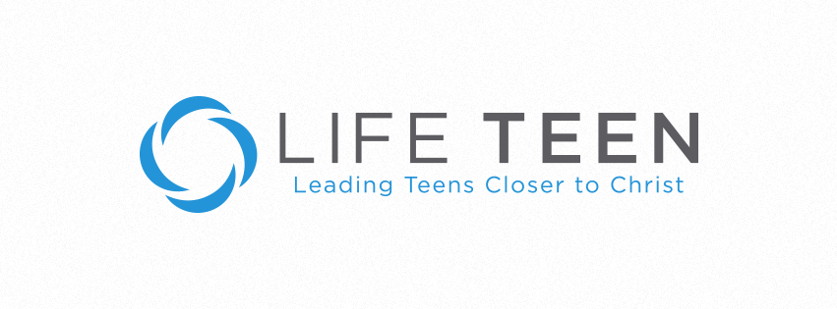
Dear Parents,

The Confirmation Retreat is right around the corner! December 5th at Silver Lake College. Please make sure they are off of work for the day. We leave at 7am and do not return until about 10 or 11pm. We will have the weekend Liturgy, so hopefully they can sleep in on Sunday morning

I need your help. Students will open letters from family, friends, sponsors, and parishes during the retreat. Will you please write them a letter? The purpose of the letter is to affirm them and encourage them. It’s your chance to write them a “love” letter from their mom and/or dad. I do not read the letters; they are between you and your senior in high school. A lot of parents talk about why they are proud of their child and their positive qualities that make them so loveable. Also, PLEASE affirm their decision to be confirmed into the Catholic Church! The only thing the letters can’t have: ANYTHING NEGATIVE. This isn’t a time to talk to them about their messy room or bad grades. Please keep it positive.

Keep this a secret! We don’t want them to know about the letters until we hand them out! You can give them to me, drop them off at Corpus, or mail them into the Corpus Christi office: 25 N. Elgin Ave Sturgeon Bay. Please have them to me NO LATER THAN DECEMBER 1ST 4:30PM.

Can you do me (well your student) another favor? Ask their siblings and other family members to write a letter too? I want them to open A LOT of letters! I want them to feel loved and supported. Cards, letters, prayer cards, whatever! Please have all letters go directly to me and not the confirmation candidate.

Thank you so much for your support!

Sarah Gavin
Stgavin25@gmail.com

