Protective Behavior Booklet

St. Anthony Parish
Niagara, WI

9th – 10th Grade

A Safe Environment Curriculum

♪ Heart Like Mine (by Bryan Duncan) ♫
Of all the hearts in the world I've only one to give. So insecure, a desperate pulse racing to Your embrace. That You could want me and seek me is more than words could ever say. That You would love me and see in me a pearl of price, thrown away.
A heart like mine, How could it be worthy that You'd find a way to redeem this hardened clay; twisted and broken. Oh Father God above the wonder that You'd love a heart like mine.
Your holy hands hold me still. Shaping my heart anew. Once vacant shell now reclaimed offers it's praise to You. The one who searched till You found me a wounded lamb whose gone astray. You stopped the world to recover me Oh Lamb of God, the price You've paid.
I make my promise to do the one thing I can do with abandon. I can give every heartbeat to You!

Prayer: O most holy heart of Jesus, fountain of every blessing, I adore you, I love you, and with lively sorrow for my sins I offer you this poor heart of mine. Make me humble, patient, pure and wholly obedient to your will. Grant, Good Jesus, that I may live in you and for you. Protect me in the midst of danger. Comfort me in my afflictions. Give me health of body, assistance in my temporal needs, your blessing on all that I do, and the grace of a holy death. Amen.
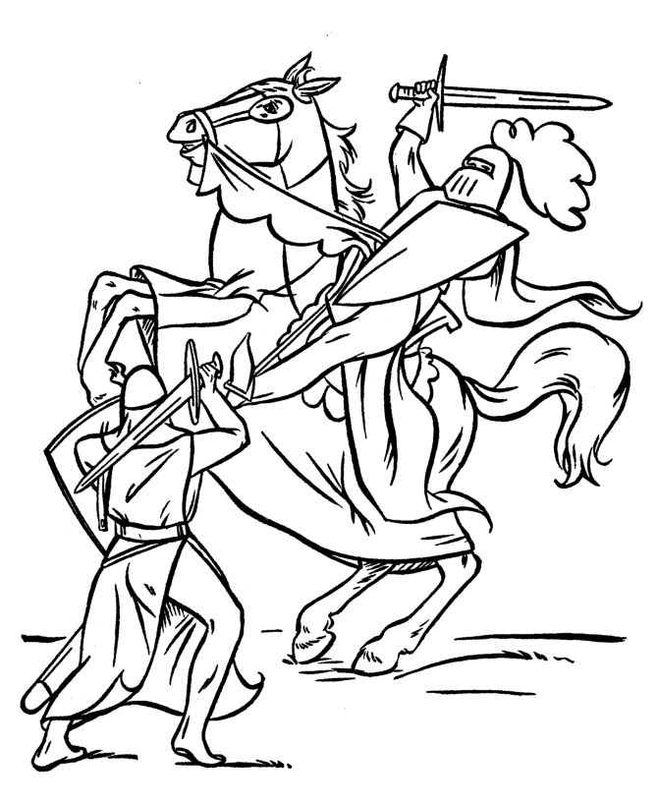
THIS MEANS WAR!
There is a battle raging…
Can you hear the canons? Can you hear the cries of agony? Do you smell the gun powder? Do you see the bodies lying on the ground? Can you feel your own wounds?

No?

That is because the battle is raging in your heart; it is SPIRITUAL WARFARE. You don’t usually see this battle with your physical senses, but your soul recognizes the conflict.

We are going to discuss in this booklet why there is a war for your ‘heart’. We will explore questions concerning God’s love for you and how to accept His love. We will confront the enemies of your heart and learn how to detect them when they are battling in your heart. We will look at three steps to discern which spirit is acting on your heart. We will conclude by looking at the weapons, defenses, allies, and supplies that you have at your disposal in this war.

God wants your happiness; your happiness now and in eternity. God made humans out of His great love and waits for them to accept His love. The angels and saints, on the side of God, all want you happy too. They are doing everything they can to help your heart choose God.

The forces of evil want you unhappy; they actually want you miserable. They are miserable because they rejected God’s love. They include Satan and his demons along with those souls who may be with him in hell. They are doing everything in their power to turn your heart away from God.

What is the ‘heart’ in this battle?
The spiritual tradition of the Church also emphasizes the heart, in the biblical sense of the depths of one's being, where the person decides for or against God (Cf. Jer 31:33; Deut 6:5; 29:3; Isa 29:13; Ezek 36:26; Mt 6:21; Lk 8:15; Rom 5:5) CCC 368

And again…
The heart is the dwelling-place where I am, where I live; according to the Semitic or Biblical expression, the heart is the place "to which I withdraw." The heart is our hidden center, beyond the grasp of our reason and of others; only the Spirit of God can fathom the human heart and know it fully. The heart is the place of decision, deeper than our psychic drives. It is the place of truth, where we choose life or death. It is the place of encounter, because as image of God we live in relation: it is the place of covenant (CCC 2563).

God doesn’t NEED you to choose Him. God is a Trinity of persons: Father Son and Holy Spirit. God is love. He doesn’t need any of His creatures to make Him happy. Yet, God in His humility, came to earth and made Himself a HEART that DESIRES us. Jesus, in His Sacred humanity, has a heart that THIRSTS for our friendship.

Discussion Questions:
How is spiritual warfare similar to a physical warfare?

In your own words, describe how the ‘heart’ is where you live.
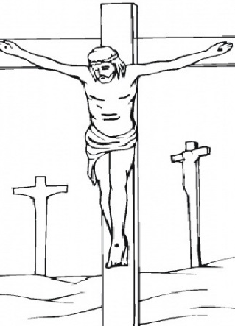
Why doesn’t God NEED us?

Does God REALLY love ME?
Jesus on the cross said, “I thirst” (Jn 19:28). Mother Teresa of Calcutta based her work with the poorest of the poor with these words of Jesus: “I thirst”. Here is part of the “I Thirst for You Prayer” based on the spiritual teachings of Mother Teresa of Calcutta:

…I thirst for you. Yes, that is the only way to even begin to describe My love for you: I THIRST FOR YOU. I thirst to love you and to be loved by you – that is how precious you are to Me. I THIRST FOR YOU. Come to Me and I will fill your heart and heal your wounds. I will make you a new creation and give you peace, even in all your trials. I THIRST FOR YOU. You must never doubt My mercy, My acceptance of you, My desire to forgive, My longing to bless you and live My life in you. I THIRST FOR YOU. If you feel unimportant in the eyes of the world, that matters not at all. For Me, there is no one any more important in the entire world than you. I THIRST FOR YOU. Open to Me, come to Me, thirst for Me, give Me your life- and I will prove to you how important you are to My Heart...

God made your heart with a deep desire for HAPPINESS. This happiness is only found in a relationship with God as He quenches your thirst for Him and you quench His thirst for you. This is the water that Jesus spoke of to the Samaritan woman at the well:
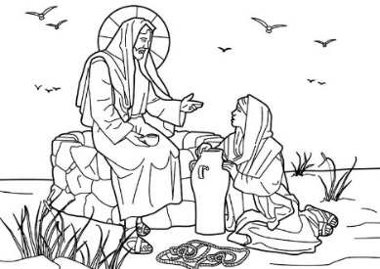
“…whoever drinks the water I shall give will never thirst; the water I shall give will become in him a spring of water welling up to eternal life” (Jn 4:13-14)

Discussion Questions:
How does a physical ‘thirst’ compare to a ‘thirst’ for returned love?

Why is our desire for happiness only fulfilled in God?

How do I receive this ‘water’ from Jesus?
This water is the very life of God. You receive it in and through the Sacraments. The very first Sacrament, Baptism, invites the Holy Spirit to dwell in your heart. When you enter your ‘heart’ and spend time with God, you drink this living water. Prayer is the doorway that allows you to enter into your heart and find refreshment with the Beloved. It is through prayer that your thirst for God may be quenched and God finds a ready heart open to His love. A great Doctor of the Church, St. Teresa of Avila wrote of prayer,

"Prayer is nothing else than a close sharing between friends; it means taking time frequently to be alone with him who you know loves us."

Her spiritual daughter, Therese of Lisieux, who is also a Doctor of the Church, wrote about her experience of prayer:

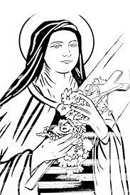
For me, prayer is an upward leap of the heart, an untroubled glance towards heaven, a cry of gratitude and love which I utter from the depths of sorrow as well as from the heights of joy. It has a supernatural grandeur which expands the soul and unites it with God.

Notice how Therese of Lisieux points to the heart as the place where prayer springs from. This brings up the question: What gets YOUR HEART to leap? Does your heart lift with the GOOD, the TRUE, and the BEAUTIFUL? Do things of the WORLD attract your heart? Does a favorite meal get your heart to leap? Does a certain boy or girl get your heart leaping? Does the heart leap when you get an expensive gift? Notice WHAT lifts your heart and WHY it is lifting. (Note: sometimes we have divided hearts that will head in different directions at different times. Pay attention to the OVERALL direction your heart is heading.)

“According to Scripture, it is the heart that prays. If our heart is far from God, the words of prayer are in vain” (CCC 2562)

Another way you can tell if your heart is for God is if you are obedient to His Word…
When God calls him, Abraham goes forth "as the Lord had told him"; Abraham's heart is entirely submissive to the Word and so he obeys. Such attentiveness of the heart, whose decisions are made according to God's will, is essential to prayer, while the words used count only in relation to it (CCC 2570).

After giving the Israelite people a summary of the laws of God, Moses told his people…
“I have set before you life and death, the blessing and the curse. Choose life…” (Deut 30:19).

Jesus told his disciples...
“You are my friends if you do what I command you” (Jn 15:14).

We live in a fallen world, so our hearts are often tempted to turn away from God. We are told in the book of Proverbs…
“Though the just fall seven times, they rise again, but the wicked stumble from only one mishap” (Prov 24:16).

Our divided heart that falls into sin is not a problem that God cannot fix. It is only when we do not turn to the mercy of God that we lose the battle for our hearts. This should encourage us in the battle to rout the enemy out of our heart by bringing these many failings into the light of God’s grace (especially through the Sacrament of Reconciliation)…

“As St. Paul affirms, "Where sin increased, grace abounded all the more." But to do its work grace must uncover sin so as to convert our hearts and bestow on us "righteousness to eternal life through Jesus Christ our Lord." Like a physician who probes the wound before treating it, God, by his Word and by his Spirit, casts a living light on sin” (CCC 1848).

Discussion Questions:
What is prayer?

How does prayer help your heart in this battle?

Can you recognize, at a conscious level, when your heart is ‘lifted’?

Who does your heart obey: God? World? Flesh? Devil?

How do we know God’s commandments?

What sin will NOT be forgiven by God?

Who are our enemies in this battle?
Your enemies are the WORLD, the FLESH, and the DEVIL. These three opponents frequently attempt to pull you away from God and the happiness God wants to give you.

For our struggle is not with flesh and blood but with the principalities, with the powers, with the world rulers of this present darkness, with the evil spirits in the heavens. (Eph 6:12)

The ‘WORLD’ is the age you live in, that frequently attracts your attention away from God and moves it to inordinate attachments. An inordinate attachment is when your heart becomes attached to something or someone that is NOT God and/or does not lead you to God. Some examples of worldly allurements may include a TV drama that entangles your heart; a popular singer that gets your heart pumping; political intrigue; obsessing about another person; etc. What are other temptations from the WORLD?

The ‘FLESH’ refers to your own body fighting against your own soul. In this battle your body wants what FEELS good. The demands of the body can sway the heart away from God. Such is the case when someone chooses to sleep in on Sunday instead of going to Mass. Can you think of other examples where your own body pulls your heart away from God?

St. Paul sympathizes with us…
“For I know that good does not dwell in me, that is, in my flesh. The willing is ready at hand, but doing the good is not. For I do not do the good I want, but I do the evil I do not want” (Rom 7:18-19).

The ‘DEVIL’ refers to Satan and his demons that are actively seeking your ruin. Our first Pope tells us…
Be sober and vigilant. Your opponent the devil is prowling around like a roaring lion looking for [someone] to devour” (1 Pt 5:8)

Jesus released many people from demonic influences while he was on earth. (Mt 12:22; Mt 4:24; Mk 5:1-20; Lk 4:33-36). He gave his Apostles the authority to deliver people from demonic influences (Lk 10:17; Acts 16:16-18). These are real enemies, even if they are not perceptible to our human senses.

The good news is that God is infinitely more powerful than the forces of evil. He has ALL the right weapons and armor. The only thing God won’t do is FORCE you to love Him. YOU need to make a decision for God all on your own. This decision is made every minute, hour, and day of your life. This is what it means to be made in the image and likeness of God; you have an intellect and free-will capable of choosing the GOOD.

God moves your heart in ways that draw you closer to Him and the fulfillment of all your desires. The evil spirits move your heart away from God and toward your ruin. The Devil will often use the world and the flesh to tempt you. He does not want you to know he is working in your life.

Discussion Questions:
Why is it important to know your enemies in a battle?

Why is it important to know how and why your enemies fight in a battle?

How do I discern which spirit is moving my heart?
In order to discern which spirit is moving your heart, you must become very aware of WHAT is ‘lifting’ your heart and WHY it is lifting (as we discussed earlier with St. Therese of Lisieux). When your heart is moved, either as a movement towards or away from God, pay attention to these movements. St. Ignatius of Loyola noticed the difference in these movements of the heart and gave us steps to help us in the battle.

(The following is taken from The Discernment of Spirits: An Ignatian Guide for Everyday Living by Fr. Timothy Gallagher.)

STEP ONE: Be aware which direction your heart is moving
Are you heading towards God and away from sin?
OR

Are you heading towards sin and away from God?

Heading TOWARDS GOD looks like someone who is trying to live a holy life. It is someone who is obedient to the commands of God, prays regularly, goes to Mass regularly, goes to Confession frequently, is kind to others, practices at least some of the Corporal and/ or Spiritual Works of Mercy, and DESIRES to do God’s will. He or she is not PERFECT, but overall tries to avoid sin and grow in virtue.

Heading TOWARDS SIN looks like people who are out to please themselves. They are not trying to live God’s commands, they do what THEY DESIRE to do and are not interested in a relationship with God. They do not want GOD telling them what to do and are resistant to talking about God. They find pleasure and happiness in things or people that pull them from God.

It is vital to be aware the overall direction your heart is heading in order to understand what is happening in this battle for your heart. You may even have a divided heart that pulls in two different directions. You may need to be brutally honest with yourself in recognizing that your heart is heading in the wrong direction – at least in some areas. Self-knowledge is necessary in this battle!

STEP TWO: Understand what is happening with your heart
IF you are heading towards God, then you will experience courage, peace, and consolation with the things of God. However, when the world, the flesh, or the devil try to pull you from God there is a sadness, disquiet, and agitation that occurs; you may even feel like you are ‘missing out’ on some opportunity.

OR

IF you are heading away from God, then you will experience pleasure from the world, the flesh, and the devil as they promise goods that they can’t deliver. When God calls there is a sadness, agitation, and disquiet.

Pay attention to who it is that is drawing you: Is it God or the enemy? This understanding is important in order to accomplish the final step.

STEP THREE: Take action
Once you are aware and understand who is calling you, then you are ready to act on this new found knowledge.

IF it is God calling to your heart, then LISTEN AND ACT on it. God’s message will give comfort for those moving towards Him and cause discomfort to those moving away from Him. Commit the message God is giving you to memory (even write it down) so you won’t forget! Stay on course – especially when it is difficult! It is common for God to lead His children by the more difficult path (Mt 7:13).

OR

IF it is the enemy speaking to your heart then DON’T LISTEN and DON’T ACT. If your heart is moving towards God then DON’T LISTEN and DON’T ACT when you are in a state of despair, anxiety, fear, or turmoil. If your heart is moving toward sin, then DON’T LISTEN and DON’T ACT when you are comfortable. You may even be completely repulsed by any thoughts of God or His Church. This is because the enemy has your heart – TAKE IT BACK!

Discussion Questions:
Restate these three steps in your own words (as if you were explaining it to a younger sibling).

Were these steps helpful to you?

Which step do you feel is the most difficult?

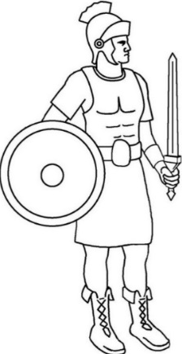
What can I do to guard against attacks by the enemy?

St. Paul tells us to…
Put on the armor of God so that you may be able to stand firm against the tactics of the devil. (Eph 6:11)

You put on the helmet of salvation when you guard your thoughts and senses so as to keep out evil. This includes guarding what shows you watch, what internet sites you visit, what music you listen to, what books you read, what thoughts you dwell on, etc. Our hope is in God; not in the fleeting distractions of the world, the flesh, and the devil.

You put on the breastplate of integrity and justice so as to guard your heart from any inordinate attachments. Love God with your WHOLE heart, soul, mind, and strength.
You put on the shield of faith when you are obedient to the teachings of the CATHOLIC CHURCH. Our FAITH is grounded on the foundation laid by Jesus when He called Peter the ROCK on which the Church is built. Like the parable of the house built on rock versus the house built on sand, a FAITH built on the ROCK of Peter will withstand the assaults of the world, the flesh, and the devil (cf. Mt 7:24-27).
You wield the two edge sword of God’s WORD when you read the Bible and pray.

You put on the belt of honesty when you seek and speak the truth at all times. This includes being honest during confession or when speaking with a counselor or spiritual guide. It is important to be honest even with yourself. Self-knowledge is vital to mature spiritual growth. The world, the flesh, and the devil are master liars and they encourage dangerous SECRETS. Learn to recognize their lies and bring their secrets into the LIGHT.

You put on the skirt of purity when you live a chaste life. Chasity is for EVERYONE. Even a married person is to live a chaste life. This includes dressing modestly, speaking with purity, living our sexuality that is in accord with God’s laws, respecting our bodies as temples of the Holy Spirit, respecting other people’s bodies as temples of the Holy Spirit, and so on..

You put on the shoes to spread the Gospel of peace when share with others your love of God. Spreading the Gospel gives you strength and strengthens the people you share the Gospel with. These shoes also remind us to allow God “to guide our feet into the path of peace” (Lk 1:79)

Therefore, put on the armor of God, that you may be able to resist on the evil day and, having done everything, to hold your ground. (Eph 6:13)

Discussion Questions:
Which piece of armor do you think is the easiest to ‘put on’?

Choose one of the pieces of armor and give a concrete example of how you can ‘put it on’.

Which piece armor do you think a person of your age would have the most difficult time wearing?

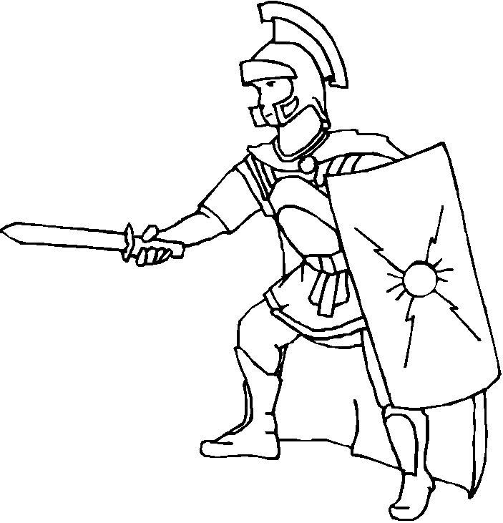
Where can I turn for help in this battle?
You are not alone in the battle for your heart. We have already spoken about prayer and putting on the armor of God as ways that you can help protect yourself from the attacks of the enemy. You also have allies in this fight. Your allies in this fight include all the Saints in heaven, which is the Church Glorious; the souls in Purgatory, which is the Church Suffering; and the souls fighting next to you in this battle, which is the Church Militant.

There are many angels protecting you and God also gave you a guardian angel to watch over you throughout your life…
“From its beginning until death, human life is surrounded by their (angels) watchful care and intercession. “Beside each believer stands an angel as protector and shepherd leading him to life." Already here on earth the Christian life shares by faith in the blessed company of angels and men united in God” (CCC 336).

Any battlefield needs a ready source of supplies. If the supply line is blocked, then the battle is over and the other side wins. The supply line in a SPIRITUAL WARFARE consists of the seven SACRAMENTS. The Sacraments are moments of grace where you encounter Jesus in a sense perceptible way. Each Sacrament has a visible and an invisible component.

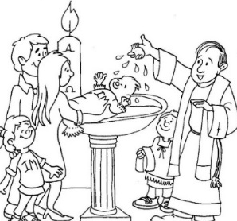
Baptism – In Baptism you are adopted into God’s family. You are now a child of the Most High God and receive all the benefits that come with this great dignity. The Holy Spirit dwells in your soul at this moment and will remain in your soul as long as you don’t let sin crowd Him out. Baptism might be compared to the access road used for the incoming supplies.

Confirmation – In Confirmation the Holy Spirit strengthens you for the battle. There is an outpouring of His gifts that are needed to keep your heart on the right path: Wisdom, Understanding, Counsel, Knowledge, Fortitude, Piety, and Fear of the Lord. Confirmation arms you for the battle. Full of these gifts, your life will show the Fruits of the Spirit: charity, joy, peace, patience, kindness, goodness, generosity, gentleness, faithfulness, modesty, self-control, chastity
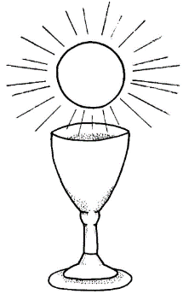
Eucharist – The Eucharist is Jesus’ own Body, Blood, Soul, and Divinity. It is the spiritual nourishment your soul NEEDS in order to live. Jesus said, “I am the living bread that came down from heaven; whoever eats this bread will live forever; and the bread that I will give is my flesh for the life of the world” (Jn 6:51). Without this food your soul starves to death.

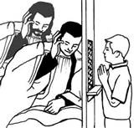
Confession – If the sin is VENIAL, then confession clears up the supply lines for easier travel. If the sin is MORTAL, then confession rebuilds burnt bridges to bring back the access route. Frequent confession is an important source of grace.

Anointing of Sick – This Sacrament gives extra help during the time the battle is fiercest. The sick and dying are physically weak but their prayers and sacrifices are all the more powerful against the forces of evil – that’s why they are attacked so fiercely! If the suffering is accepted and united to Jesus on the Cross, then the suffering can even be redemptive. Redemptive suffering helps others in their battle of the heart (CCC 1502-1505)

Marriage – The Sacrament of Marriage raises up more soldiers for the battle. It is the job of parents to guard the hearts and minds of their children. Marriage also gives you a friend to watch your back and help you in your fight. It is the job of spouses to help each other get to heaven.

Holy Orders – The Sacrament of Holy Orders ordains the leaders of the battlefield. Without the priesthood we have NO SACRAMENTS; no supply line.

Discussion Questions:
Do you speak with your guardian angel?

Do you know of any saints that you could develop a friendship with?

Which Sacrament are you the most familiar with? Why?

Can you see the battle lines now?
You have discovered that there is a battle for your ‘heart’. There are many battles in this WAR for your heart. Sometimes it is a daily battle as we need to continually choose to serve GOD rather than the enemy.

God doesn’t need you to accept His love, but that is what fulfills your deepest desire. Your enemies want you to be miserable in this life and in the next life. These enemies tempt you with things, people, or situations that APPEAR to be good, but are really moving your heart from God. Thankfully, God has provided you EVERYTHING you need to win each battle in this war for your heart.
- Through putting on the armor of God you can protect yourself from the attacks of the enemy.
- Through the Sacraments you receive the divine life in your soul, supplying you with all you need.
- Through prayer you relate to God in an intimate friendship
- Through your obedience to God’s commands you show you trust in His merciful love and are less likely to get hurt in the battle for your heart
- Through an awareness of the movements of your heart, you can learn of the movements and strategies of your enemy.
- Through the help of your allies, you are given support to help guard your back.

Prayer to Put on the Armor of God
Heavenly Father, in the Name of Jesus, I ask you to put on me and those I pray for: the helmet of salvation, which is hope; the breastplate of integrity and justice, which is love; the shield of faith; the two-edged sword, which is the Word of God; the belt of honesty; the skirt of purity; and shoes to spread the Gospel of peace. Amen.

