Protective Behavior Booklet

St. Anthony Parish
Niagara, WI

7th - 8th Grade

A Safe Environment Curriculum

♪ Circle Of Friends (by Point of Grace) ♫
We were made to love and be loved. But the price this world demands will cost you far too much. Spent so many lonely years just tryin' to fit in. Now I've found my place
In this circle of friends.

In a circle of friends, we have one Father
In a circle of friends, we share this prayer. That every orphan soul will know and all will enter in to the shelter of this circle of friends

If you weep, I will weep with you. If you sing for joy the rest of us will lift our voices too. But no matter what you feel inside there's no need to pretend. That's that way it is in this circle of friends
(Refrain)

Among the nations, tribes, and tongues we have sisters and brothers and when we meet in Heaven we will recognize each other. With joy so deep, and love so sweet we'll celebrate these friends and life that never ends
(Refrain)

That it will not be long before all will enter in
To the shelter of this circle of friends. Circle of friends...
A Guardian Angel Prayer for Friends

Guardian Angel, watch over those whose names you can read in my heart. Guard over them with every care and make their way easy and their labors fruitful. Dry their tears if they weep; sanctify their joys; raise their courage if they weaken; restore their hope if they lose heart, their health if they be ill, truth if they err, and repentance if they fail.

“In the beginning was the Word, and the Word was with God, and the Word was God. He was in the beginning with God. All things came to be through him, and without him nothing came to be. What came to be through him was life, and this life was the light of the human race; the light shines in the darkness, and the darkness has not overcome it” (John 1:1-5).

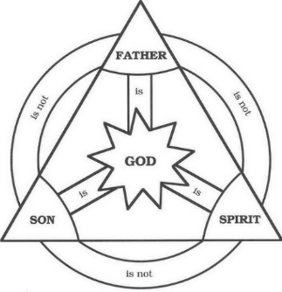
God is a communion of persons: Father, Son, and Holy Spirit. God, having no need to create anything, brings humans into existence. Made in His image and likeness, God offers His love and life to humans. Adam and Eve didn’t trust God and GRASP for themselves what appears to be good. Even though He is rejected by His creatures, God still seeks a relationship with His people. He goes so far as to enter into the world of His creation in order to redeem what was lost and He remains in the world to guide His friends.

The Blessed Trinity images for us what it means to love. The Father, in His role of Creator, reveals a love that pours itself on others. This is an example of a GENEROUS love. The Son, in His role as Redeemer, reveals a love that suffers for the beloved. His is an example of SACRAFICIAL love. The Holy Spirit, in His role as Sanctifier, reveals a love that consoles the beloved. His love is ABIDING, as He lives in the souls of the faithful. There are so many more examples of love from the Trinity…Can you think of others?

Jesus prayed to the Father…
“I pray not only for them, but also for those who will believe in me through their word, so that they may all be one, as you, Father, are in me and I in you, that they also may be in us, that the world may believe that you sent me” (Jn 17:20-21).

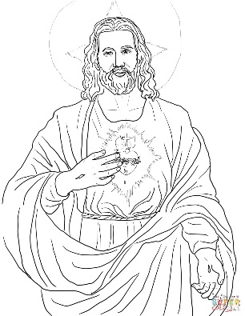
The desire of Jesus’ Sacred Heart is for unity. A unity between God and humanity and a unity among people. Any true friendship is a glimpse of the communion of Persons found in the Blessed Trinity. A true friendship with another person will have God as the center in order for the friendship to last into eternity. It will also have similar qualities to the friendship God calls His children to enter into with Him.

“I no longer call you slaves, because a slave does not know what his master is doing. I have called you friends, because I have told you everything I have heard from my Father” (Jn 15:15).

Jesus, coming to earth and revealing His Father’s will, invites us into a friendship with Him. The Blessed Trinity: Father, Son, and Holy Spirit seek to be your BEST FRIEND FOREVER. This is not a simple acquaintance type of friendship; God wants a friendship so intimate and loving that He compares it to a marriage.

“For as a young man marries a virgin, your Builder shall marry you; And as a bridegroom rejoices in his bride so shall your God rejoice in you” (Is 62:5)

As members of His Church, we make up the Body of Christ…

“Now you are Christ’s body, and individually parts of it” (1 Cor 12:27).

The Church is the BRIDE of Christ…
“For no man ever hates his own flesh, but nourishes and cherishes it, as Christ does the Church, because we are members of his body. ‘For this reason a man shall leave his father and mother and be joined to his wife, and the two shall become one.' This is a great mystery, and I mean in reference to Christ and the Church. However, let each one of you love his wife as himself, and let the wife see that she respects her husband" (Eph 5:21-33).

The example Jesus gives us as He died for His bride reveals His deep love and commitment to us and it reveals what it means to be a true friend…

“No one has greater love than this, to lay down one’s life for one’s friends” (Jn 15:13).

Jesus tells us what it takes to be His friend…

“You are my friends if you do what I command you” (Jn 15:14).
There is not a whole lot of wiggle room in this statement. In order to be a friend of God we need to follow what Jesus teaches us. This may take a lifetime of learning, so get started NOW!

Discussion Questions:
Do you recognize that God wants YOU for a friend? Why or why not?

How do you feel when you hear that God wants to ‘marry’ you?

What does it mean to be in the ‘Body of Christ’? What does it look like?

Do you feel you know what Jesus ‘commands’ you to do in order to be His friend? What are some of those commands?

Should any other human person say you must do what he/she ‘commands’ you to do in order to be his or her friend?

As we continue in this booklet, we will look at what it means to be a true friend to God and a true friend to others. Then we will discuss how to form a true friendship in our daily life. Finally, we will discuss how to arm ourselves against those who are false friends or outright enemies.

What is a TRUE FRIEND?
A true friendship is one based on LOVE. It is wanting only what is GOOD for the other person. The greatest GOOD is growing in our friendship with God; therefore, a true friend helps us grow in virtue. There is also an affection for the other person; you LIKE being with him or her. In theological terms these ideas are referred to as charity and benevolence.

Many great thinkers have pondered this very question of ‘what is a true friend?’ These great thinkers began by identifying what true friendship is NOT. With slight variations, they labeled two types of friendships that are NOT a true friendship of love but are readily available in this world:

- They noted that there is a type of friendship based primarily on feelings. This is a friendship of pleasure. We really feel good when we are with this friend, but we just don’t care about growing in virtue together. This is a very common type of friendship with young children. They change friends frequently because they only want to be with someone as long as it FEELS good. (Unfortunately, some people never mature enough to form any other type of friendship)

- There is another type of friendship we form as we have common goals with another person. A united mission helps form a friendship, but this type of friendship is primarily about the goal to be accomplished. It is known as a friendship of utility because our only reason to be together is because it is mutually self-serving. This type of friendship is readily found in sport teams which spend so much time together during the ‘season’ but then don’t bother calling ‘off season’. As soon as the goal is accomplished there is no more NEED to be with this person.
(cf. Aristotle in Nicomachean Ethics)

Qualities of a true friendship:
- It is limited to a select few people in your life
- It is reciprocal in that there is a mutual charity and benevolence
- It is a sharing of one’s very heart and soul with another person
- It is among equals in that neither person feels superior to the other
- It aids you and your friend in your love of God and others
- It helps both parties to grow in virtue and avoid vice
- It unites two people so there is a mutual conformity of ideas
- It bears good fruit in this life and the next because it continues in heaven.
- It lasts forever (on earth and in heaven)

Let’s explore some of these qualities…
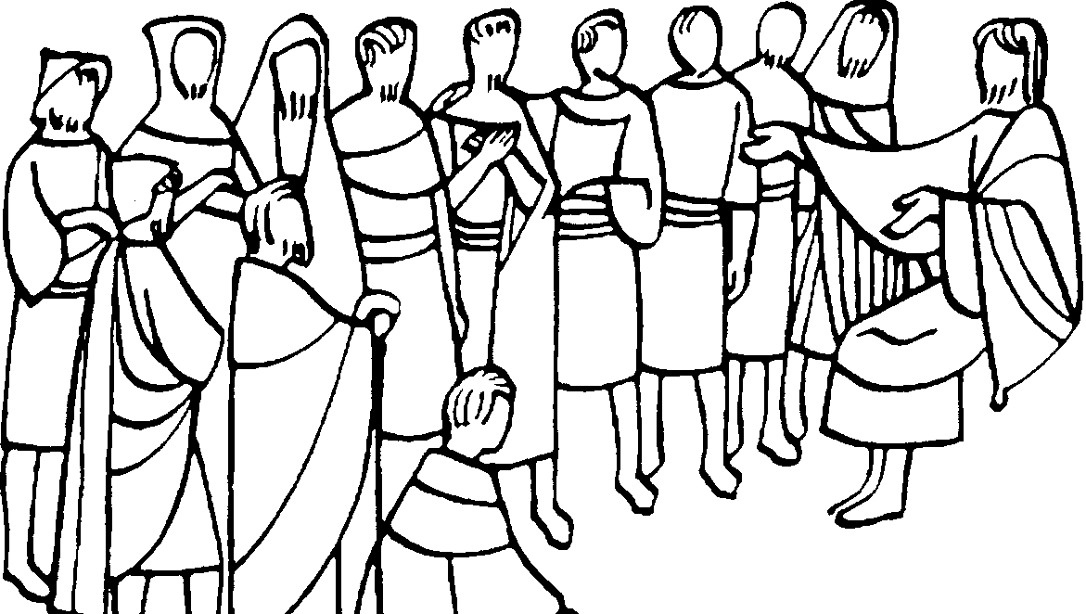
A true friendship is not a common occurrence. It is not the childish type of friendship that wants EVERYONE as a friend; that is impossible until we live in heaven. As Christians we are required to love EVERYONE “If possible, on your part, live at peace with all” (Rom 12:18). However, because we live in a fallen world, we need to be selective in who we choose into our intimate friendship. Jesus chose His 12 Apostles and, on many occasions, shared only with them the meaning of His words. Sometimes, Jesus even chose 3 of the 12 Apostles to share special moments (cf. Mt 17:1; 26:37). A true friendship of love takes time to cultivate and grow. It requires spending time with a person and communicating thoughts and desires. One needs to test a potential ‘friend’ to make sure they are capable of a true friendship of love.

Aelred of Rievaulx wrote a book on Spiritual Friendship, where he recommends
A four step plan in choosing a friend:
- Select someone who is living a virtuous life. Someone who you feel is at your level, you enjoy being with, and might be a potential TRUE friend. Obviously, this person must return your interest in forming a friendship or otherwise it is doomed to failure. St. Thomas Aquinas stated “Yet neither does well-wishing suffice for friendship, for a certain mutual love is requisite, since friendship is between friend and friend: and this well-wishing is founded on some kind of communication” (ST 2, II, 23, 1). So begin by spending time in conversation with your potential friend.

- Have a probationary period of time where you get to know this friend and see if he/she is loyal, heaven is his/her life goal, if he/she is discrete, and if he/she is patient. “So by their fruits you will know them” (Mt 7:20). At this stage, take time to be with your friend to share ideas and reveal a little bit of your heart. If you find he/she is not a good match for you, feel free to slowly “unstitch” this friendship with charity. Again, we are called to LOVE everyone, but we do not need to trust everyone with our intimate thoughts and feelings. If someone does something to completely BETRAY your offer of friendship through vice, feel free to break the friendship immediately (but still with charity).

- Admit this person into your friendship if he/she has proven to be a true friend. At this stage there is a mutual sharing of hearts and souls in intimate communication with the beloved other. Cicero said that “A friend is the medicine of life” as he recognized the great gift of a TRUE FRIEND.

- Live in perfect harmony as you grow in your friendship with God and each other. A true friendship lasts forever; truly a BFF! Not even death can separate true friends as they continue their friendship in heaven. A true friendship will produce GOOD fruits within your lives and those around you as your shared love spurs each other into GOOD WORKS.
Many of the Saints had true friends that helped them on their journey to heaven. Their example can give us a wonderful image of a true friendship. These friends are now both recognized by the Church as living in heaven: Teresa of Avila and John of the Cross; Therese of Lisieux and her parents, Louis and Zelie Martin; Louise de Merillac and Vincent de Paul; Ignatius of Loyola and Francis Xavier; Francis of Assisi and Clare; Perpetua and Felicity; Augustine and Monica; Scholastica and Benedict; Rose of Lima and Martin de Porres; Catherine of Siena and Pope Gregory XI; and Francis de Sales and Jane de Chantal. Just to name a few…

Can I be friends with boys and girls?
As you can see, many times God puts together people of the opposite sex to form a true friendship. They may be husband and wife; sister and brother; mother and son; or just a man and a woman who love God. God made men and women to be complementary. This means that males and females are different, but the differences work together in a beautiful way. Men and women are capable of a true friendship as long as they practice the virtue of chastity.

“The virtue of chastity blossoms in friendship.” (CCC 2346).

“Chastity is expressed notably in friendship with one’s neighbor. Whether it develops between persons of the same or opposite sex, friendship represents a great good for all. It leads to spiritual communion” (CCC 2347).

The Catechism of the Catholic Church teaches us that chastity “means the successful integration of sexuality within the person and thus the inner unity of man in his bodily and spiritual being” (CCC 2337). Until we have this inner unity within ourselves, we are not going to be able to have a unity (or true friendship) with another person. The Catechism continues by telling us what we need to do in order to practice chastity and form true friendships…

“Chastity includes an apprenticeship in self-mastery which is a training in human freedom. The alternative is clear: either man governs his passions and finds peace, or he lets himself be dominated by them and become unhappy…” (CCC 2339).

Discussion Questions:
What might the traits of a true friendship mentioned earlier look like in YOUR life? Choose one and give a concrete example.

In your own words, what are the steps to choosing a true friend? What would you add or subtract from these steps?

Do you have anyone that you would consider a ‘true friend’? What stage would you put the person that is closest to a ‘true friend’ if you don’t have a ‘true friend’ yet?

In your own words, describe how men and women are complementary? Give some examples.

What is chastity?

Why does CHASTITY blossom into FRIENDSHIP?

What does it mean to have “an apprenticeship in self-mastery”?

What are the ‘passions’? Why do they make us unhappy if they are not controlled?

Who are my enemies?
Our enemies are the WORLD, the FLESH, and the DEVIL. These three opponents frequently attempt to pull us away from God and the happiness God wants to give us; the happiness that is only found in a true friendship with God.

For our struggle is not with flesh and blood but with the principalities, with the powers, with the world rulers of this present darkness, with the evil spirits in the heavens. (Eph 6:12)

The WORLD is the age we live which frequently attracts our attention away from God and towards excessive attachments. This enemy is not the world itself as created by God including nature and the animals; rather, one example might include the movies or other entertainments that draw us into the DRAMA of other people’s lives. Do you recognize how getting involved in other people’s DRAMA can pull you from God?

“Do not conform yourselves to this age but be transformed by the renewal of your mind, that you may discern what is the will of God, what is good and pleasing and perfect” (Rom 12:2).

The FLESH refers to our own body fighting against our own soul. In this battle our body wants what FEELS good. Our intellect must be formed to recognize our TRUE GOOD and the will must choose this GOOD over what FEELS good. St. Paul tells us…

“For I know that good does not dwell in me, that is, in my flesh. The willing is ready at hand, but doing the good is not. For I do not do the good I want, but I do the evil I do not want” (Rom 7:18-19).

The Devil refers to Satan and his demons that are actively seeking your ruin. Our first Pope, Peter, tells us…

Be sober and vigilant. Your opponent the devil is prowling around like a roaring lion looking for [someone] to devour” (1 Pt 5:8)

How do I guard against these enemies?
St. Paul tells us to…

Put on the armor of God so that you may be able to stand firm against the tactics of the devil. (Eph 6:11)

What is the armor of God?
We put on the helmet of salvation when we guard our thoughts and senses so as to keep out evil. This includes guarding what shows we watch, what internet sites we visit, what music we listen to, what books we read, what thoughts we dwell on, etc. Our hope is in God; not in the fleeting distractions of the world, the flesh, and the devil.

We put on the breastplate of integrity and justice when we guard our hearts so as to love God first and other people second. Even in a true friendship with another person, our love of God must be the foundation of our life and our love. We must be willing to give up a friendship, if it is drawing us away from God. (If a ‘friendship’ draws us from God, it is NOT a true friendship).

We put on the shield of faith when we are obedient to the teachings of the CATHOLIC CHURCH. Our FAITH is grounded on the foundation laid by Jesus when He called Peter the ROCK on which the Church is built. Like the parable of the house built on rock versus the house built on sand, a FAITH built on the ROCK of Peter will withstand the assaults of the world, the flesh, and the devil (cf. Mt 7:24-27).
We wield the two edge sword of God’s WORD when we read the Bible and pray. Do you read the Bible daily? How do you pray?

We put on the belt of honesty when we seek and speak the truth at all times. The world, the flesh, and the devil are master liars. They also want us to keep dangerous SECRETS. Learn to recognize their lies and bring their secrets into the LIGHT.

We put on the skirt of purity when we live a chaste life. Chasity is for EVERYONE. Even a married person is to live a chaste life. This includes dressing modestly, speaking with purity, living our sexuality that is in accord with God’s laws, respecting our bodies as temples of the Holy Spirit, respecting other people’s bodies as temples of the Holy Spirit, and so on. We spoke earlier about the importance of chastity in forming friendships.

We put on the shoes to spread the Gospel of peace when share with others our love of God. Spreading the Gospel gives us strength and strengthens the people we share the Gospel with.

Therefore, put on the armor of God, that you may be able to resist on the evil day and, having done everything, to hold your ground. (Eph 6:13)

Discussion Questions:
Can you give examples of ‘worldly’ temptations?

Can you give examples of ‘fleshly’ temptations?

Can you give examples of temptations from the devil?

Choose one of the pieces of armor and give an example on how we ‘put on’ that piece of armor.

Which one of the pieces of armor do you think is the hardest for a person your age to ‘put on’? Why?

The Roman soldier did not have armor on his back – why? Because his friends were supposed to protect him and he was supposed to protect his friend. They fought back to back. Choose friends that will protect you from harm and make sure you are a true friend to others.

Prayer to Put on the Armor of God
Heavenly Father, in the Name of Jesus, I ask you to put on me and those I pray for: the helmet of salvation, which is hope; the breastplate of integrity and justice, which is love; the shield of faith; the two-edged sword, which is the Word of God; the belt of honesty; the skirt of purity; and shoes to spread the Gospel of peace. Amen.

