Protective Behavior Booklet

St. Anthony Parish
Niagara, WI

K-2nd Grade

A Safe environment curriculum

♪ O Be Careful, Little Eyes ♫
O be careful little eyes what you see. O be careful little eyes what you see. For the Father up above is looking down in love so, be careful little eyes what you see

O be careful little ears what you hear. O be careful little ears what you hear. For the Father up above is looking down in love so, be careful little ears what you hear

O be careful little tongue what you say. O be careful little tongue what you say. For the Father up above is looking down in love so be careful little mouth what you say

O be careful little hands what you do. O be careful little hands what you do. For the Father up above is looking down in love so, be careful little hands what you do

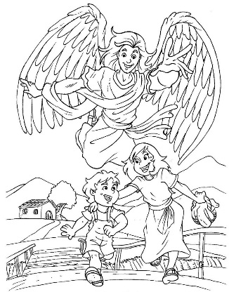
O be careful little feet where you go. O be careful little feet where you go. For the Father up above is looking down in love so, be careful little feet where you go

Prayer:
Angel of God, my guardian dear, to whom God's love commits me here, ever this day, be at my side, to light and guard, to rule and guide. Amen.
Safe
There are many things that help keep us safe.
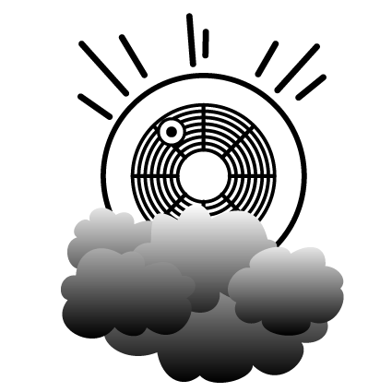
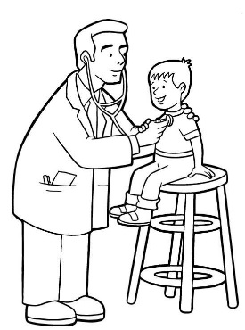
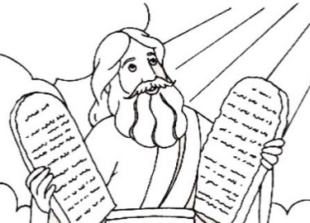
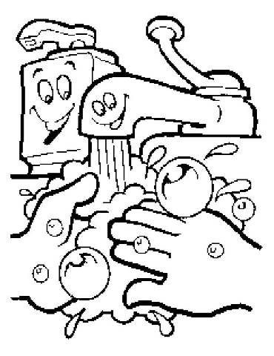
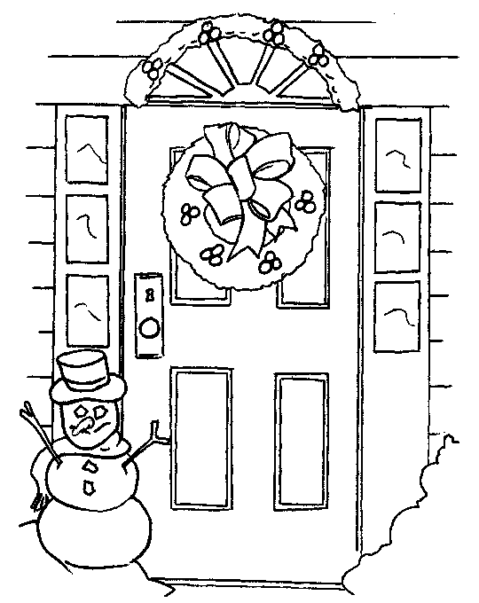

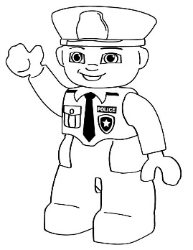

Listen to your teacher and decide if the situations are safe or not. Use your guardian angel on the front page to say “safe” and use your stop sign on the back to say “unsafe”
God creates the soul of every person.

Today God is creating a new soul that will live forever.

Every person deserves to be treated with respect because humans are made in the image and likeness of God

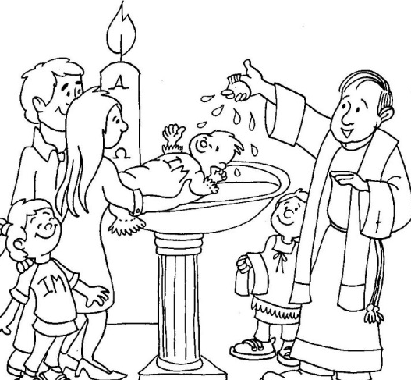
God adopts us into His family when we are baptized. We are God’s children now.

Since God is the King of the universe; that makes you a prince or princess
God cares for us and wants to protect us
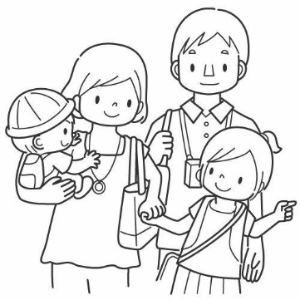

We are born into a family that loves and cares for us…

We have a community of people to help us

We are given a Guardian Angel to watch over us

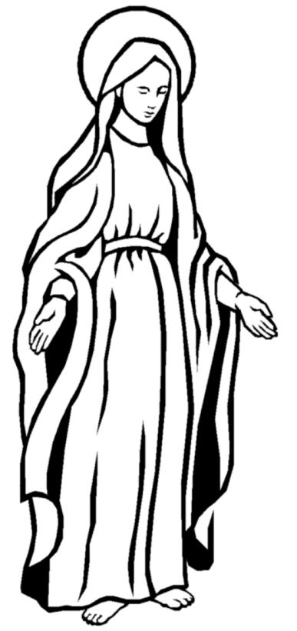
All the Saints in heaven pray for us; especially Jesus’ own mother, Mary.
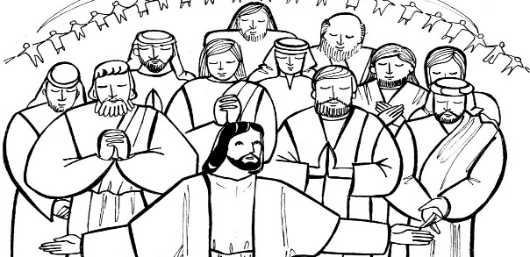

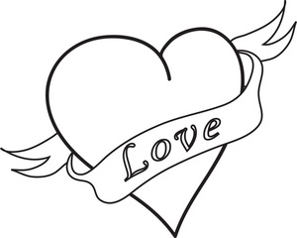
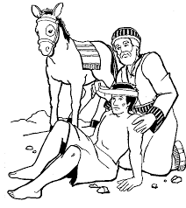
God’s Law is written in our heart. It is a law of LOVE

We can know right from wrong if we follow our well-formed conscience.

Our conscience gives us an “uh-oh” feeling if we are doing something that isn’t safe. We may feel sick, get a tummy ache, feel like crying, or feel like we are going to get in trouble if an adult finds out.

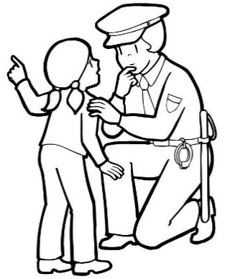
We need to tell someone we trust right away if we get that feeling so we can feel safe again. It is NOT tattling when it is about your safety!!

Do you have at least 5 people you trust and could talk to when you don’t feel safe?

Write the name of someone you trust on each finger of this hand

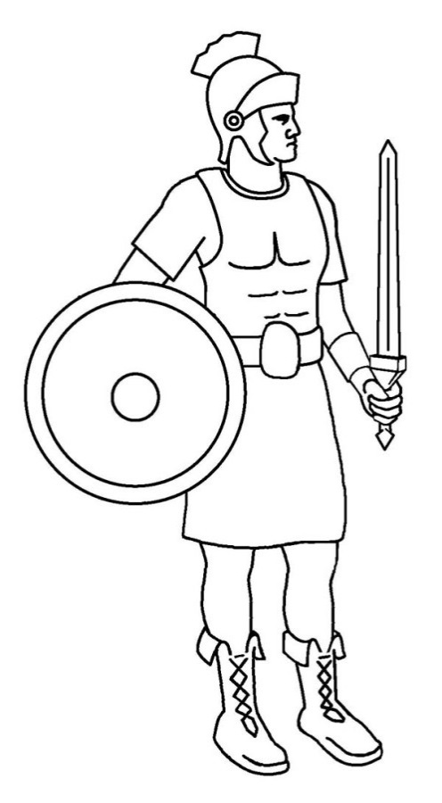
Put on the Armor of God (Eph. 6:13-17)

The helmet protects our eyes, ears, and mind. We need to be careful about what shows we watch, games we play, the words we hear, the pictures we see, the thoughts we think…

The breastplate protects our heart. We need to be careful about what we “love”. Don’t get attached to things: TV, movies, games, toys, etc. Make sure we love God and others, like God wants us to love them.

The Shield is our Faith in God and all He has taught us.

The Sword is the WORD OF GOD. That means we need to read our Bible and pray in order to learn what God wants us to do.

The belt is for honesty. We need to speak the truth all the time. People can’t protect us if we lie or keep secrets that are harming us.

The “skirt” like armor protects the private parts of our body. We need to wear our clothes and not let others see or touch our private areas (unless a doctor or parent needs to help you). We shouldn’t try looking at or touching the private parts of other people’s bodies either.

The shoes bring us where we need to go. We need to let our parents, teachers, and/or guardian know where we are at all times.

Prayer to Put on the Armor of God
Heavenly Father, in the Name of Jesus, I ask you to put on me and those I pray for: the helmet of salvation, which is hope; the breastplate of integrity and justice, which is love; the shield of faith; the two-edged sword, which is the Word of God; the belt of honesty; the skirt of purity; and shoes to spread the Gospel of peace. Amen.

