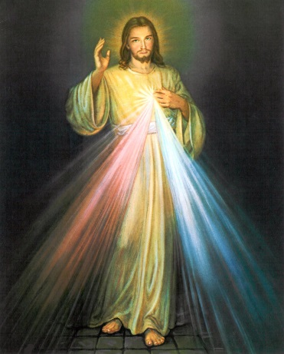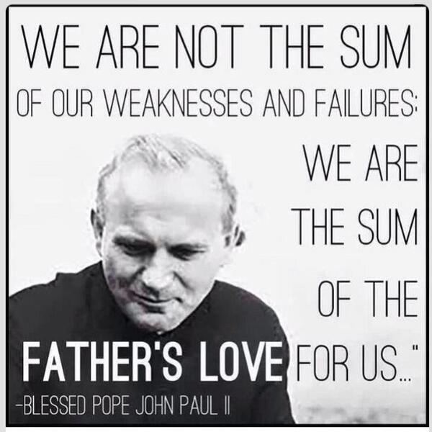

Examination of Conscience for

High School

Diocese of Green Bay

Office of Youth Ministry

**How to Celebrate the Sacrament of Penance**

1. Father greets you and you greet him
2. You and Father make the Sign of the Cross
3. Father says this prayer or something similar: “May the Lord be in your heart and help you to confess your sins with true sorrow.”
4. You begin the confession of my sins by saying: “Bless me Father for I have sinned, my last confession was ___ months/years ago).
5. Tell your sins.
6. Finish by saying, “I am sorry for these and for all my sins.”
7. Father talks with you about my confession. He asks me to do my penance. He will then ask you to pray the Act of Contrition:

My God, I am sorry for my sins with all my heart. In choosing to do wrong and failing to do good, I have sinned against you whom I should love above all things, I firmly intend, with your help, to do penance, to sin no more, and to avoid whatever leads me to sin. Our Savior Jesus Christ suffered and died for us. In His name, my God, have mercy. Amen.

Or

O my God, I am heartily sorry for having offended Thee, and I detest all my sins because of Thy just punishments, but most of all because they offend Thee, my God, Who art all-good and deserving of all my love. I firmly resolve, with the help of Thy grace, to sin no more and to avoid the near occasions of sin. Amen.

1. Father says the words of absolution. Bow your head to receive God’s forgiveness. Make the Sign of the Cross as Father says, “And I absolve you from your sins in the name of the Father, and of the Son, and of the Holy Spirit.” Answer: AMEN
2. Father might say the following prayer:   
   Father: Give thanks to the Lord for He is good.

Your Answer: His mercy endures forever.

**“Every time you go to confession, immerse yourself entirely in My mercy, with great trust, so that I may pour the bounty of My grace upon your soul. When you approach the confessional, know this, that**

**I Myself am waiting there for you.”**

**– Diary of St. Faustina**

**Fifth Commandment: You shall not kill.**

* Have I born hatred or malice against another, wished someone evil, desired revenge, or refused to forgive injuries or hurts?
* Have I refused to show the ordinary signs of friendship to my relatives and friends, refused to speak to others?
* Have I led others into sin? Have I taught others to commit sin?
* Have I in any willful manner caused the death of another by neglect or a positive act, such as abortion?
* Have I seriously considered taking my own life? Did I actually attempt to do so?
* Have I been intemperate in eating or drinking?
* Have I been drunk?
* Have I used any illicit drugs? What example did I give to others?

**Sixth and Ninth Commandments: You shall not commit adultery. You shall not covet your neighbor’s wife.**

* Have I willfully entertained impure thoughts?
* Have I been involved in illicit sexual activity with another person?
* Have I indulged in pornography or masturbation?
* Have I sent impure messages or pictures?
* Am I pure in my thoughts, words, actions? Am I modest in my dress?
* When I go out on dates, can the other person tell by what we do and what we don’t do that I am a Catholic?
* Am I engaged in any inappropriate relationships?

**Seventh and Tenth Commandments: You shall not steal. You shall not covet your neighbor’s goods.**

* Have I taken anything which was not my own?
* Have I injured another’s property or interests?
* Do I cheat at school?
* Have I failed to do sufficient work for the wages I receive at work?

**Eighth Commandment:** You shall not bear false witness against your neighbor.

* Have I unjustly injured the reputation of another through false statements, or by exposing his/her faults without necessity?
* Have I listened with pleasure to the gossip or hurtful statements made by people about others?
* Have I rashly misjudged others, or falsely suspected them?
* Do I reveal information that should be confidential?

**Commandments of the Church**

* Do I fast for one hour before receiving Holy Communion? Have I failed to fast and abstain when I was not excused by a sufficient reason?
* Have I received Confession and Holy Communion at least once a year during the Easter season?
* Do I contribute to the support of my parish and charities according to my means?

**First Commandment: I am the Lord your God, you shall not have strange gods before me.**

* Am I trying to find God in my life? If I have doubts or struggles in my faith, am I trying to be open to what God is asking of me?
* Have I denied the Lord through my actions and words; in the entertainment I choose to read, watch, or listen to?
* Have I omitted my prayers or other practices of my faith because of what others would think?
* Have I boasted of sin? Despaired of God’s mercy or doubted it?
* Have I neglected to examine my conscience sufficiently, and thus omitted a serious sin?
* What are the false gods in my life – popularity, friends, desires, relationships, clothes, self?
* Do I take seriously my responsibility to attend and to learn about my faith through religion classes in the parish?
* How well do I know the Scriptures? Do I spend time on a regular basis reading God’s Word? When was the last time I shared my faith with others?

**Second Commandment: You shall not take the name of the Lord your God in vain.**

* Have I used the name of God thoughtlessly, or in cursing?
* Have I spoken irreverently about the saints or holy things, about the Church, Church practices, customs, or ceremonies?
* Am I aware of the power of my example – that the way in which I speak using God’s name will teach others to respect His name?
* What am I saying to God when I use his name irreverently or loosely?

**Third Commandment: Remember to keep holy the Lord’s day.**

* Jesus gave the Church the most powerful prayer at the Last Supper when He instituted the Eucharist. This is the gift for which Jesus gave his life and which he comes to us sacramentally. Do I try to understand and appreciate the Mass?
* Have I failed to attend Mass on Sundays or Holy Days of Obligation without a sufficient reason? Was I late on a regular basis? Did I leave before the end of Mass? Is this a habit?
* Have I been distracted during Mass? Have I distracted others? Have I failed to listen to the sermon?
* Have I performed unnecessary work on Sundays?

**Fourth Commandment: Honor your Father and Mother**

* Without my parents I would not be. Do I show the necessary respect for my parents through my words and actions?
* Do I thank my parents for all they do for me or have I failed to help them when they needed help? Failed to pray for them?
* Have I failed to pray for relatives and others who have died and may be in need of my prayers?
* Do I show proper respect toward teachers and other authority figures?