Protective Behavior Booklet

TEACHER GUIDE

5th - 6th Grade

A Safe Environment Curriculum

Protective Behavior
St. Anthony Parish
Grades 5 & 6

Learning Objectives:
God wants happiness for all His children
The Armor of God keeps us safe from harm
Real love if free, total, faithful, and fruitful
Men and women are complimentary
Emotions help, but do not control our love
Define chastity

♪ The Joy of the Lord By Twila Paris ♫
The joy of the Lord will be my strength. I will not falter, I will not faint. He is my Shepherd, I am not afraid. The joy of the Lord is my strength

Refrain:
The joy of the Lord; The joy of the Lord; The joy of the Lord is my strength

The joy of the Lord will be my strength. He will uphold me all of my days. I am surrounded by mercy and grace. And the joy of the Lord is my strength

Refrain 2x

The joy of the Lord will be my strength. And I will not waiver, walking by faith. He will be strong to deliver me safe. And the joy of the Lord is my strength

Refrain 4x

Prayer: Jesus, Mary and Joseph, I entrust and consecrate myself entirely to you - mind, heart and body. Guard and defend me always from every sin. May my mind be uplifted to heavenly things, may my heart love God more and more, may I avoid every evil occasion. Hold me close to you, so that I may keep watch of my internal and external senses. Preserve me from all impurity, and help me to serve you with undefiled mind, pure heart and chaste body, so that in heaven I may join the blessed company of the saints. AMEN

God made you and wants you to be happy…

What is happiness?

Let’s go back to the beginning to find out…

In the beginning God made man in His own image and likeness…

What does that mean?

It means humans have an intellect and free will. Humans can reason things out with their mind and choose the good (what will make them happy). Humans desire good, unfortunately we see an APPARENT good and can mistake it for a REAL good.

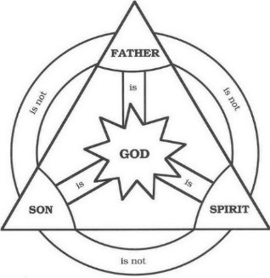
In making humans in His own image and likeness, God invites humans to become His sons and daughters. God is a Trinity of Persons: Father, Son, and Holy Spirit. God is love. He shares his love and life with humanity, but allows them to choose to love Him back or not. Love must be free in order for it to be real love. No one can force someone to love them. Why can’t we force someone to love us? Give examples of why love must be freely given; can we pay someone to love us? Can we train someone to love us (like a dog)? We may be able to force someone to ACT like they love us, but love NEEDS to be freely given in order for it to be called ‘love’.
Real Love is freely given and freely received…

God notices that Adam is alone and He says that it isn’t good for Adam to be alone, so God makes Eve from Adam’s rib. In making another human person, God invites Adam and Eve to relate to one another and to Him. Men and women are made different so that they can work together. They are what we call ‘complementary’. That doesn’t mean Adam gives Eve a compliment like, “nice hair”. It means they have different gifts that work together. Adam and Eve are perfectly happy and find their happiness in each other’s happiness. God says it is VERY GOOD when He sees Adam and Eve together. The object here is to get the students to see that men and women have different physical, emotional, and spiritual gifts that work together. Ask for them to give you examples of those differences working together. Hint: how is you mom different from your dad? How do they work together?

Here is where the story becomes tragic…

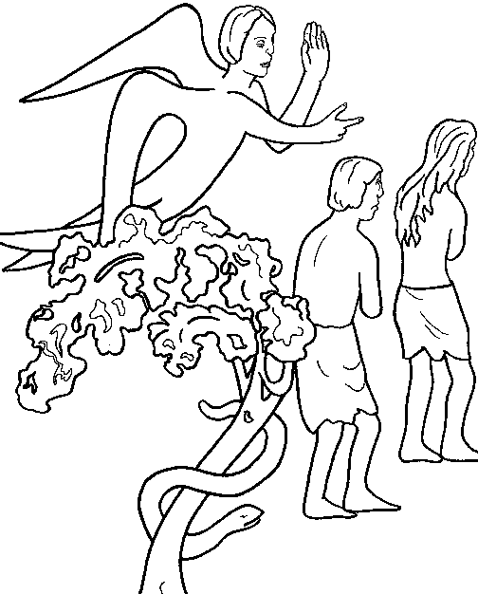
Adam and Eve don’t trust God and GRASP for themselves what they think is good. They use their gifts of intellect and free will against God and commit the first sin. Original sin causes a division between God and man; and divisions among people. Plenty of examples available from life on how people are divided against one another…

God banishes Adam and Eve from the perfect home where they lived as a family. Sin brings division to the family. God wants to heal the family. The division between God and man needs a special person to fix that broken relationship because it needs to be someone who is God and human. God has a plan, but He waits until just the right time. Even though Adam and Eve are not faithful, God is always faithful. Real love is faithful. What does it mean to be faithful? Why is it important to be faithful to someone you love? Being faithful is when you love someone even if you don’t know WHY you love them. It means forgiving people and being open to fixing a broken relationship. Without faithfulness, we might give up on a good friend when we don’t feel like being friends anymore.
Real love is faithful…

In the meantime, Adam and Eve realize that their broken relationship has consequences. One of their sons kills another one of their sons; plants don’t grow as easily; animals are not as friendly; it hurts to have babies; they are inclined to make themselves happy rather than each other. They have lost the happiness they had in the Garden of Eden.

After many, many years, God the Father sends His only begotten Son, Jesus, to earth. Jesus is that special person that can fix the relationship with God and humans because Jesus is 100% God and 100% human.
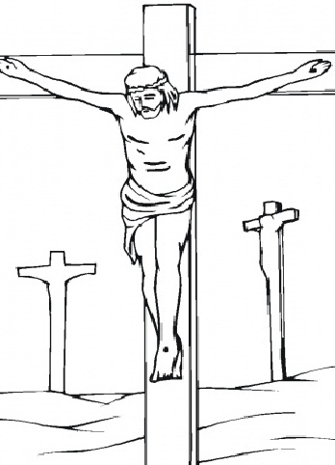
Jesus lives on earth and shows people how to act as a child of God. How do we act if we are God’s child? He teaches people, heals people, and forms friendships with people. Jesus suffers and dies on the cross in order to heal the relationship between God and human beings. Jesus shows us that real love involves sacrifice; real love makes a gift of oneself to others; real love gives EVERYTHING – it says, “I am totally yours”. Why is this type of love usually reserved for relationships like a married man and woman or a parent and child? In what way may we make a total gift of ourselves to others?
We only have so much time, energy, and other resources at our disposal to give to others. Our close family is our responsibility and so they have a right to everything we have. That being said, St. Paul gives us an idea on how we can make a total gift of ourselves to others when he said, “Whatever you do, do from the heart, as for the Lord and not for others” (Col 3:23). If all our heart, soul, mind, and strength is centered on God. If all our words and deeds are said and done as if FOR GOD, then we are making a TOTAL gift of ourselves to others. If time permits discuss the different types of love: storge, philia, eros, and agape
Storge is the love of natural fondness or caring, like in a family. Philia is a friendship love consisting of sharing thoughts and activities. Eros is an emotional connection between two people – it MAY be, but isn’t necessarily, romantic or sexual in nature. Agape is the love of God; it is sacrificial and unconditional. These loves can be mixed and matched in many different ways and intensities within one relationship.
Real love is a TOTAL gift of oneself to the beloved…

Jesus shows us that suffering and death cannot hurt a child of God because Jesus rises from the dead. After Jesus’ Resurrection, He goes home to heaven and tells us He is preparing a place for us there. God wants His children happy and gives us all the graces we need to be happy with Him in this life and in heaven. Make sure they understand that suffering and death may hurt in the moment, but it won’t hurt when we are with God in heaven. Explain that grace = God’s gifts (there are internal and external graces from God; some are help for our body and some for our soul)
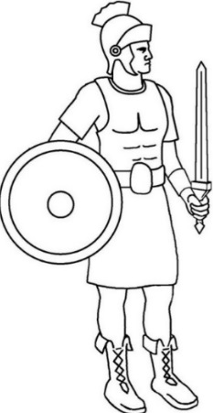
Jesus goes to heaven, but He leaves His friends the Holy Spirit to guide them. The Holy Spirit comes to live in our soul at Baptism and stays with us as long as we continue to keep our souls clean. When we keep our souls clean it is called being in a ‘State of Grace’. When we live in a State of Grace we are wearing the ARMOR OF GOD. We live in a world still affected by Original Sin, and the Armor of God protects us physically, emotionally, and spiritually from harmful relationships. At this point, ask if anyone has any questions.

Helmet of salvation, which is hope
- Protects our mind from bad thoughts
- Protects our eyes from evil images
- Protects our ears from evil words

By limiting our senses, we are protected from the curiosity that may lead us into situations that are dangerous to our body and soul. It is kind of like the blinders people put on horses so they aren’t spooked. The horse can only see straight ahead. The helmet of salvation keeps us focused on God.

- The Helmet helps us use our imagination and emotions in ways where we experience the good, true, and beautiful. You may want to define: Good = what is best for us, what we desire; True = the reality of what IS; Beautiful = beholding that which is good and true (i.e. the Beatific vision)

- The Helmet helps us desire and pursue the good, true, and beautiful Do you pursue violence and sassy attitudes in your entertainment? Do you desire and pursue entertainments and /or people that lift your heart and mind to God?

- The Helmet helps us Hope in God’s promise of eternal happiness with Him in heaven.

What are ways you can put on the helmet of salvation in your life? Be careful on what you seek for entertainment. Avoid people or situations that are not helping you love God better.
Give examples of good and bad curiosity (studiosity vs curiosity).. Good curiosity, or studiosity, helps you uncover a truth that will help you and others (like scientific discoveries, solving puzzles, asking why or how something works) Bad curiosity is putting yourself in a situation that is NONE of YOUR BUSINESS. (like gossiping or listening to gossip, wanting to know something that isn’t good for you to know)

Breastplate of integrity and justice, which is love
LOVE is more than an emotion. It is an act of the will – you choose to love someone or not. Just like Adam and Eve had a choice to love God or not. In loving someone we are using the free-will that God gives us. Note: this is the love we are obliged to give to everyone. If time permits, discuss the different kinds of love: for family, for a child, for a spouse, for friends, for acquaintances, for enemies, etc.

Love is willing the good of the other.
- Loving someone means that you help them make good decisions.
- Loving someone means that you help them learn about God.
- Loving someone means that you pray for them to God.
- Loving someone means practicing Spiritual and Corporal Works of Mercy Corporal Works: To feed the hungry; To give drink to the thirsty; To clothe the naked; To shelter to the homeless; To visit the sick; To visit the imprisoned; To bury the dead.
The spiritual works of mercy are: To instruct the ignorant; To counsel the doubtful; To admonish sinners; To bear wrongs patiently; To forgive offences willingly; To comfort the afflicted; To pray for the living and the dead.

Emotions are a “FEELING” you get in various circumstances and towards people
- Emotions are neither good nor bad – they just are
- Emotions can, and MUST, be controlled so that you don’t make a decision based on your emotions – they do not live in the control center of YOU.

If you FEEL love for someone that FEELS good and helps you be nice to someone

If you FEEL angry with someone that doesn’t FEEL good and may lead you to be mean to someone.

If you FEEL fear in a situation that FEELING may help you avoid a person or situation that is unsafe.

Emotions are like people in a bus. They can yell or talk to the driver of the bus, but the driver is the one that actually drives; that is your intellect and free will. If everyone in the bus is shouting to turn left, but the driver/intellect knows he needs to turn right, it is his responsibility/free will to turn right! Sometimes the people in the bus support and help the driver, and sometimes they distract the driver and tell him to go in the wrong direction. Have you ever experienced your emotions telling you to do something you shouldn’t do? Allow discussion on emotions getting out of control…
The catechism tells us “Feelings or passions are emotions or movements of the sensitive appetite that incline us to act or not to act in regard to something felt or imagined to be good or evil” (CCC 1764).

“The principal passions are love and hatred, desire and fear, joy, sadness, and anger” (CCC 1772).

GAME: Listen to your teacher and pray about each scenario. Use your intellect and free will to choose what you think is God’s plan for your happiness:
If there is a question of morality, make sure you are clear on God’s plan for their happiness; otherwise allow for different answers to the scenarios and discuss.
i. You are angry with a friend who said something that hurt you…what do you do?
ii. You are excited to watch a PG-13 movie that everyone says is so good (but you know it has words and scenes that are bad)… what do you do?
iii. You are very happy with your friends, but one of them starts pointing out how stupid one of your classmates acted in class…what do you do?
iv. You are enjoying a well-deserved rest on Sunday morning when you realize Mass starts in 45 minutes… what do you do?
v. Someone you like wants to be your “boyfriend/girlfriend”… what do you do?
vi. Your friends want to hang out at a place that makes you uncomfortable… what do you do?
vii. There is an adult that gives you the ‘creeps’ whenever they are around…what do you do?
viii. Your friend is wearing a dress that is really short and shows a lot of skin…what do you do?
ix. You are invited to a birthday party and they are planning to see a movie you know your Mom or Dad does not want you to see…what do you do?
x. You are afraid to go the dentist…what do you do?

Shield of Faith:
Our Catholic Faith, if we live it, can protect us from harm and bring us into right relationship with God and others Discuss what it means to LIVE out FAITH: externally and internally using the list below…

What are ways we carry our shield of faith?
- The Sacraments – especially the Eucharist and Confession, which we can receive frequently

- Prayers of the community (family, friends, Saints, Mary, Parish, catechists, etc.)

- Living the Ten Commandments and the Beatitudes
THE TEN COMMANDMENTS
1. I AM THE LORD THY GOD: THOU SHALT NOT HAVE STRANGE GODS BEFORE ME.
2. THOU SHALT NOT TAKE THE NAME OF THE LORD THY GOD IN VAIN.
3. REMEMBER TO KEEP HOLY THE LORD'S DAY.
4. HONOR THY FATHER AND THY MOTHER.
5. THOU SHALT NOT KILL.
6. THOU SHALT NOT COMMIT ADULTRY.
7. THOU SHALT NOT STEAL.
8. THOU SHALT NOT BEAR FALSE WITNESS AGAINST THY NEIGHBOR.
9. THOU SHALT NOT COVET THY NEIGHBOR'S WIFE.
10. THOU SHALT NOT COVET THY NEIGHBOR'S GOODS.

THE BEATITUDES
1. Blessed are the poor in spirit, for theirs is the kingdom of heaven.
2. Blessed are they who mourn, for they will be comforted.
3. Blessed are the meek, for they will inherit the land.
4. Blessed are they who hunger and thirst for righteousness, for they will be satisfied.
5. Blessed are the merciful, for they will be shown mercy.
6. Blessed are the clean of heart, for they will see God.
7. Blessed are the peacemakers, for they will be called children of God.
8. Blessed are they who are persecuted for the sake of righteousness, for theirs is the kingdom of heaven.

- The Holy Spirit living in our souls provides us with the gifts of Wisdom, Understanding, Counsel, Knowledge, Piety, Fortitude, and Fear of the Lord.

The Catechism tells us that, if we let Him, the Holy Spirit will even help us use our emotions to accomplish God’s plan (cf. CCC 1769).

God wants us to use our WHOLE being to know, love, and serve Him. The first, and greatest commandment is to love God with ALL our HEART, SOUL, MIND, and STRENGTH (cf. Mt 22:37). This includes guiding our emotions to love God. Kind of like the bus driver ‘guides’ the passengers on the bus.
Two edged sword: the Word of God
Learning what God has taught us through Sacred Scripture and Tradition can protect us from the attacks from the world, the flesh, and the devil.

The teaching office of the Church, called the Magisterium, will help us apply what is in Sacred Tradition and Scripture to the challenges we face today.

The example of the saints and people from the Bible can help us see that making good decisions is possible even in difficult situations.

What Saint or Bible character has taught you a good lesson? If they don’t know, give some examples (like David is an example of complete trust in God; Abraham is an example of faithfulness; St. Perpetua is an example of courage; Thomas Aquinas is an example of using one’s mind for the Kingdom of God; etc)

Belt of honesty
God is the Way the TRUTH and the Life (cf. Jn 14:6). Our Enemies are master liars and want us to keep dangerous SECRETS. Recognize their lies and bring dangerous secrets into the LIGHT. Give examples of secrets that are dangerous: Your friend tells you she plans to commit suicide tonight; You are in a ‘friendship’ where the other person is hurting you; Your friends plan to sneak out of the house and go to a party that might harm them;

Always speak the truth in LOVE. St. Paul tells us we should only say good things to people that will help build them up in their friendship with God (cf. Eph 4:29). Sometimes we have to say something that corrects bad behavior, but if we do it with LOVE then it is helpful. How can we correct someone’s behavior without ‘judging’ them? Objective truth reveals if someone’s behavior is with or against God’s laws. We are NOT judging if a person is going to heaven or hell – that is up to JESUS! We are looking at the behavior and loving the person enough to say, “hey, watch out!” HOW we correct them is subjective – it will depend on the persons, the situation, and your responsibility towards that person (a parent has more responsibility in correcting the bad behavior of their child than a co-worker)

Jesus tells us we are going to be held accountable for every idle word we speak (cf. Mt 12:36).

The Catechism tells us that we aren’t being truthful if we gossip about someone; hurt someone; cause someone to believe a lie; hurt someone’s reputation; or make an assumption that something is TRUE about someone when it may not be (CCC 2477).

What are ways you can put on the belt of honesty? Allow discussion…

Skirt of purity (or chastity)
The skirt of purity protects the areas of our bodies that distinguishes us as male or female. These private areas should not be touched or revealed to others and we should not try seeing or touching these private areas on other people. We keep our private areas private (discuss the difference between public and private: your house is private, the grocery store is public; a bathroom stall is private, even if it is in a public bathroom). Being modest also means keeping to yourself any bad words or thoughts (again the difference between public and private)

The Catechism tells us “chastity lets us love with upright and undivided heart;” (CCC 2520). We can love God and each other with a pure heart when we practice chastity.

“Chastity means the successful integration of sexuality within the person and thus the inner unity of man in his bodily and spiritual being” (CCC 2337). A person who is chaste knows his or her identity as a son or daughter of God and is comfortable with that identity in their daily life. Unity in our bodily and spiritual being recognizes the truth of our maleness or femaleness.

The Catechism also teaches us the importance of self-mastery where we are completely free from letting our passions or emotions take charge. If we can’t control our passions or emotions, then we are unhappy. Humans are not animals – we can control how we respond to our FEELINGS (cf. CCC 2339).
Why are people who are “out of control” not very happy people? Do you know anyone in this predicament?

“Chastity includes an apprenticeship in self-mastery which is a training in human freedom. The alternative is clear: either man governs his passions and finds peace, or he lets himself be dominated by them and become unhappy. ‘Man’s dignity therefore requires him to act out of conscious and free choice, as moved and drawn in a personal way from within, and not by blind impulses in himself or by mere external constraint. Man gains such dignity when ridding himself of all slavery to the passions, he presses forward to his goal by freely choosing what is good an d, by his diligence and skill, effectively secures for himself the means suited to this end’” (CCC 2339).

“Indeed it is through chastity that we are gathered together and led back to the unity from which we were fragmented into multiplicity” (CCC 2340 from St. Augustine).

This process will take a lifetime to accomplish. It is especially hard for children and teenagers (cf. CCC 2342). Why do you think self-mastery is harder for children and teens? What could adults do to help you in this struggle? Here is a link to the marshmallow experiment done on self-control. https://www.youtube.com/watch?v=QX_oy9614HQ

“Self-mastery is a long and exacting work. One can never consider it acquired once and for all. It presupposes renewed effort at all stages of life. The effort required can be more intense in certain periods, such as when the personality is being formed during childhood and adolescence” (CCC 2342).

“Chastity presupposes respect for the rights of the person, in particular the right to receive information and an education that respect the moral and spiritual dimensions of human life” (CCC 2344).’
“The virtue of chastity blossoms in friendship.” (CCC 2346).

“Chastity is expressed notably in friendship with one’s neighbor. Whether it develops between persons of the same or opposite sex, friendship represents a great good for all. It leads to spiritual communion” (CCC 2347). Discuss how we can have friends who are male and friends who are female. Why are friends such a great good?
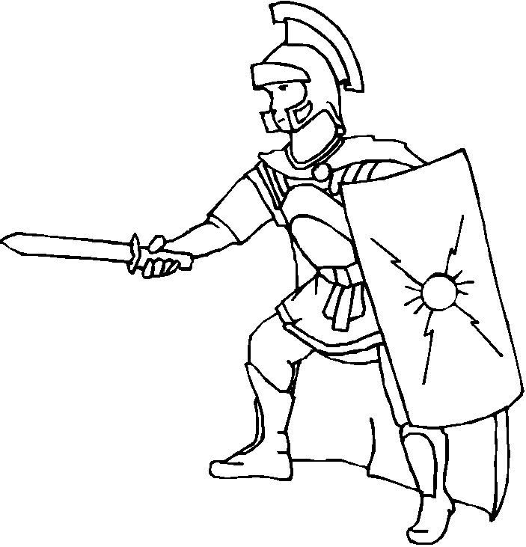
The Roman soldier did not have armor on his back – why? Because his friends were supposed to protect him and he was supposed to protect his friend. They fought back to back. Choose friends that will protect you from harm and make sure you are a good friend to others.

Who are your friends?
GOD Family
Community Friends
Mary Guardian Angel
Saints in heaven

David didn’t fit into Saul’s armor so he picked up five stones in order to slay Goliath. Do you have five people that you trust to help you feel safe? Write their names in the stones… If you have time and the students haven’t heard about David and Goliath, you could give a quick summary. Discuss how we are sometimes faced with a person or situation that is way BIGGER than we can handle. These situations require us to call on HELP from those we trust. Have them write the name of five people they trust on the stones below, like David choosing the five stones for his sling.

Shoes to spread the Gospel of peace
Putting on these shoes reminds us that we are to be good examples to others. Through our friendships, we help other people grow in their friendship with God. We must make sure we only go to the places God sends us.

When we have the Holy Spirit living in us and wear the Armor of God, we produce the FRUITS OF THE SPIRIT. The Fruits are charity, joy, peace, patience, kindness, goodness, generosity, gentleness, faithfulness, modesty, self-control, chastity This reveals another aspect of love…Discuss what these fruits look like in a young person’s life.
Real love is FRUITFUL!

We began by asking: What is happiness?

Happiness is living in an intimate, personal friendship with God. We will not be PERFECTLY happy until we are in heaven, but we can experience a taste of this happiness on earth as we live with the Holy Spirit dwelling in our soul.

We also get a glimpse of this perfect happiness in our friendships with one another…

Prayer to Put on the Armor of God
Heavenly Father, in the Name of Jesus, I ask you to put on me and those I pray for: the helmet of salvation, which is hope; the breastplate of integrity and justice, which is love; the shield of faith; the two-edged sword, which is the Word of God; the belt of honesty; the skirt of purity; and shoes to spread the Gospel of peace. Amen.

