Protective Behavior Booklet

Teacher Guide

K-2nd Grade

A Safe environment curriculum

Learning objectives:
- God made every person. (MAKE SURE YOU COVER THE STORY OF CREATION AND ADAM & EVE BEFORE DOING THIS LESSON)
- God loves us and wants to keep us safe from harm
- God put His Law of Love in our hearts to guide us
- God gives us guardian angels, family, friends, community, and armor to protect us

Materials Needed:
- Song “Oh Be Careful Little Eyes”
- Lesson plan
- Handouts:
  - Booklet for each student to color and take home

♪ O Be Careful, Little Eyes ♫
O be careful little eyes what you see. O be careful little eyes what you see. For the Father up above is looking down in love so, be careful little eyes what you see

O be careful little ears what you hear. O be careful little ears what you hear. For the Father up above is looking down in love so, be careful little ears what you hear

O be careful little tongue what you say. O be careful little tongue what you say. For the Father up above is looking down in love so be careful little mouth what you say

O be careful little hands what you do. O be careful little hands what you do. For the Father up above is looking down in love so, be careful little hands what you do

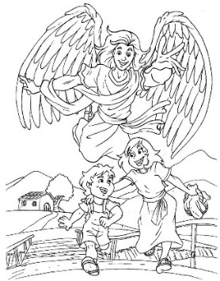
O be careful little feet where you go. O be careful little feet where you go. For the Father up above is looking down in love so, be careful little feet where you go

Prayer:
Angel of God, my guardian dear, to whom God's love commits me here, ever this day, be at my side, to light and guard, to rule and guide. Amen.
Safe
There are many things that help keep us safe.
Go through pictures and talk about how each one keeps us safe
A smoke alarm warns us of a possible fire. Go through the plans for escape if the alarm goes off (take time to talk about the escape route from the classroom for fire and tornado).
Talk about traffic safety, crossing streets, and what would happen if someone didn’t stop at stop sign.
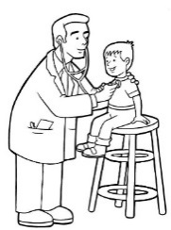
Doctors help us when we are sick. Talk about shots, vitamins, eating healthy, exercise, and other preventative medicine

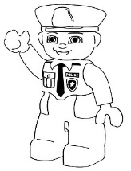
Police officers keep us safe from speeding cars, people who might do something illegal (like steal or hit someone – don’t mention items that might be too scary)
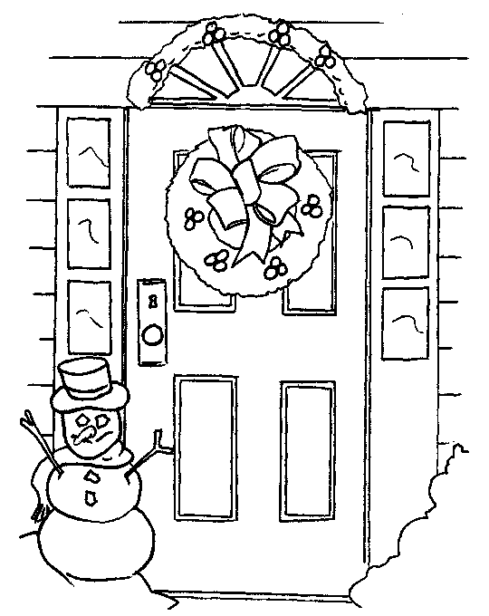
A closed door protects us from the cold, heat, and from people who shouldn’t be walking through our house.

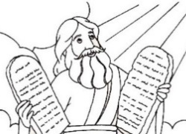
God gave Moses the 10 Commandments to protect His people from the harm of sin. Talk about how God’s laws keep us safe.
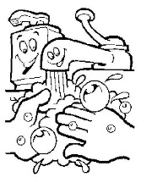
Soap and water keeps us safe from germs. Talk about proper handwashing techniques.

Listen to your teacher and decide if the situations are safe or not. Use your guardian angel on the front page to say “safe” and use your stop sign on the back to say “unsafe”
    - Running outside
    - Running outside with scissors in your hand
    - Playing catch with your friend
    - Playing catch with your friend in the street
    - Help carry out the garbage
    - Digging in the garbage and throwing it on the floor
    - Telling an adult when you go outside
    - Staying close to an adult while at the store
Feel free to add your own scenarios.
God creates the soul of every person. God doesn’t store up souls somewhere. He creates our souls while we were so small that no one even knew we existed yet

Today God is creating a new soul that will live forever. God keeps on working in our world. He is still creating, not just at the beginning of the world. Our soul never dies

Every person deserves to be treated with respect because humans are made in the image and likeness of God
Talk about how humans desire good and can use their mind to think about all sort of things.

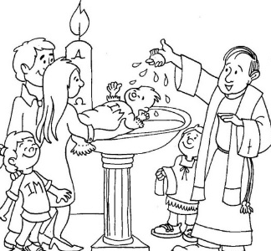
God adopts us into His family when we are baptized. We are God’s children now.
Discuss the Sacrament of Baptism. Ask if anyone has seen someone get baptized. Discuss what they SEE and what they DON’T SEE. We can’t see the SEAL God has placed on our soul claiming us as His child
Since God is the King of the universe; that makes you a prince or princess. Discuss how a prince or princess should be nicer and more generous than other people. Discuss the dignity of being a child of God.

God cares for us and wants to protect us God is a good and caring FATHER. Make sure they have a positive understanding of FATHER. If not by experience, then by your words to them…

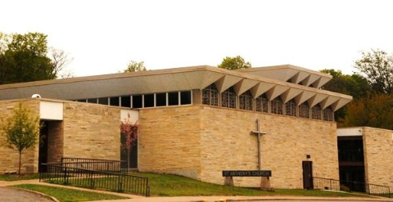
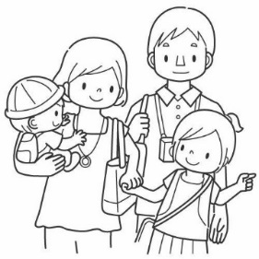
We are born into a family that loves and cares for us… Give students a chance to talk about their experience of a caring family. Ask, “How do your parents/guardians take care of you?” If someone is sharing bad experiences. Make sure to redirect and address the concern after class. Allow a conversation that is geared to the most innocent child in the class.

We have a community of people to help us Talk about our parish family and how the pastor, catechists, and other parishioners pray for them and are concerned about their safety.

We are given a Guardian Angel to watch over us Discuss the care of angels, specifically their guardian angel. Make it concrete for them by having them imagine a room full of angels watching over each student. Maybe ask, “What do you want to ask your guardian angel?” or “What would you say if you saw your guardian angel?” (NOTE: Bible characters who see angels are told “Do not be afraid”).

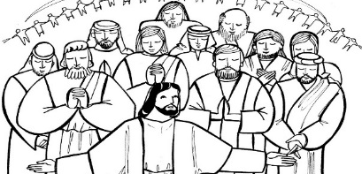
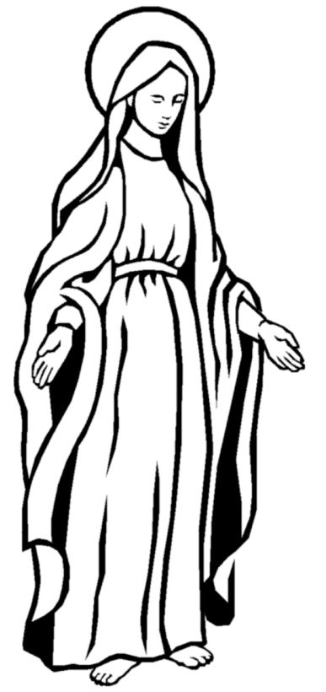
All the Saints in heaven pray for us; especially Jesus’ own mother, Mary. Discuss how all the saints in heaven are part of our big parish family. We have grandmas and grandpas that we may never have met praying for us. Also talk about Mary and her motherhood to ALL God’s children.

God’s Law is written in our heart. It is a law of LOVE
Discuss how they can know something is wrong even if they weren’t told it was wrong. Talk about what it means to LOVE someone: wanting the best for someone.

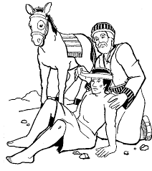
We can know right from wrong if we follow our well-formed conscience. A well-formed conscience will make you feel bad when you do something against God’s laws.

Our conscience gives us an “uh-oh” feeling if we are doing something that isn’t safe. We may feel sick, get a tummy ache, feel like crying, or feel like we are going to get in trouble if an adult finds out. Talk about this as being good and a way God protects us from harm. Give some simple examples like feeling guilty if we take a cookie our Mom told us not to take; or feeling nervous is we are about to jump our bike off a ramp.

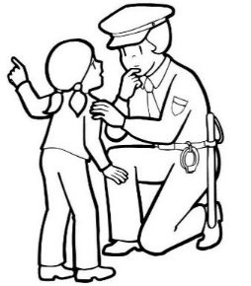
We need to tell someone we trust if we get that feeling so we can feel safe again. Remind the students that all those people who love and care for them do not want them to have that icky feeling and want to help them feel safe again.

Do you have at least 5 people you trust and could talk to when you don’t feel safe?
Write the name of someone you trust on each finger of this hand Hand out pencils for them to write the name of the people they trust. You will need to help with spelling some names…

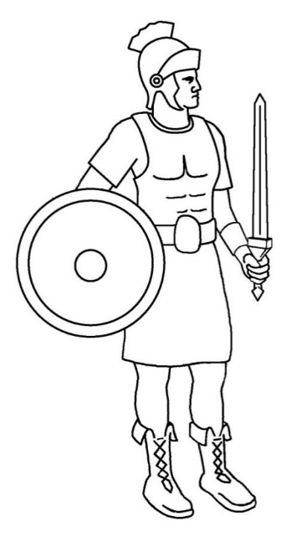
Put on the Armor of God (Eph. 6:13-17)
They can color each item as you go through them and discuss how each piece keeps them safe. Make sure they know they need to wear this armor to stay safe. If they don’t listen to their parents, and a well-formed conscience, then they are putting themselves at RISK. Remind them of those dangers you discussed earlier (like germs, and speeding cars, and cold weather, tummy aches from eating the wrong food, and strangers, etc.)

The helmet protects our eyes, ears, and mind. We need to be careful about what shows we watch, games we play, the words we hear, the pictures we see, the thoughts we think…Have you ever watched a movie or TV show that gave you a nightmare? Should you watch shows that give you an icky feeling? NO
Remind them of the song “O Be Careful little eyes”. Talk about their ears hearing bad or mean words. Talk about their mind thinking something mean. Talk about how they can leave a room or block their eyes and ears if something is on TV that they shouldn’t watch.

The breastplate protects our heart. We need to be careful about what we “love”. Don’t get attached to things: TV, movies, games, toys, etc. Make sure we love God and others, like God wants us to love them. Is there a toy or game you would get super mad if someone touched?

The Shield is our Faith in God and all He has taught us. Remind them that this is why they come to Religious Education classes; they are trying to learn what God teaches. We also learn when we go to MASS.

The Sword is the WORD OF GOD. That means we need to read our Bible and pray in order to learn what God wants us to do. Ask if they have a children’s Bible at home that someone could read to them. Ask if they know any stories from the Bible.

The belt is for honesty. We need to speak the truth all the time. People can’t protect us if we lie. Give an example of the dangers of lying: One such example is when I was a little girl (4yrs old) I hid in the little refrigerator in our camper. My little sister (3 yrs old) told our Dad that I hid in there – even though I told her NOT TO TELL (we were playing hide-and-seek with our older sister). I would have suffocated in that refrigerator if she kept that secret.

The “skirt” like armor protects the private parts of our body. We need to wear our clothes and not let others see or touch our private areas (unless a doctor or parent needs to help you). We shouldn’t try looking at or touching the private parts of other people’s bodies either. Maybe talk about little girls when they wear skirts and how they need to sit nice. Also tell little boys they need to not look if a girl is sitting wrong.
The shoes bring us where we need to go. We need to let our parents, teachers, and/or guardian know where we are at all times. Talk about some of the places they are allowed to go. Are there any places they are NOT allowed to go? Why is it good for your parents/ guardians to know where you are? Why is it important for YOU to know where your parents / guardians are?

Prayer to Put on the Armor of God
Heavenly Father, in the Name of Jesus, I ask you to put on me and those I pray for: the helmet of salvation, which is hope; the breastplate of integrity and justice, which is love; the shield of faith; the two-edged sword, which is the Word of God; the belt of honesty; the skirt of purity; and shoes to spread the Gospel of peace. Amen.

