St Mary Winneconne
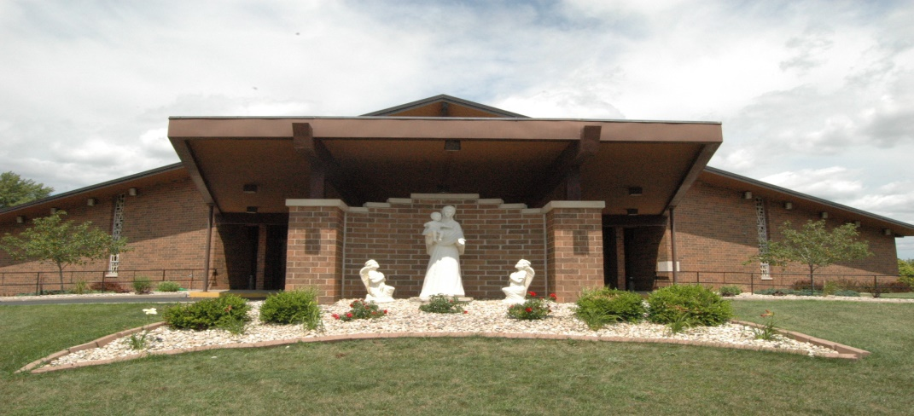
2nd Grade Sacramental Preparation Handbook

2nd Grade Sacramental Preparation
The Catholic sacraments are gifts that are grounded in the life and ministry of Jesus and have been defined over time through the wisdom and experience of the Church. By the power of the Holy Spirit, and through the essential actions of the sacraments, Jesus is present in his Church today to welcome, strengthen, nourish, heal and empower us to live holy lives and to continue his work.
The Eucharist is the sacrament of initiation which is the spiritual core of Catholic life and provides ongoing nourishment and strength for members of our Church. Penance/Reconciliation is a sacrament of spiritual healing and conversion in which we strive to be in a healthy relationship with God, others and ourselves.
In our second grade classes, the first part of the year will focus on preparation for the Sacrament of First Reconciliation. The second half of the year will focus on preparation for First Eucharist. In these pages, you will find a schedule, information about the sacraments, tips on your role as a parent, and information regarding requirements.

Parents, as primary educators of their children, are responsible for preparing them for the sacraments of initiation. They should strive to be models of moral living, constant faith, and forgiveness. During these months, your child will be experiencing a very important part of his or her spiritual growth. We want to
support your child, and your entire family, to get the most out of the experiences
of this time.

With the support of our parish religious education program, parents should prepare their child for these sacramental encounters and for life in as a Catholic Christian in the following ways:
- Modeling Catholic life by receiving the Sacraments regularly, even after the first sacraments are celebrated.
- Maintaining a regular prayer life in the home
- Reviewing the basic prayers with your child
- Attending meetings sponsored by the parish in preparation for Penance
- Review the catechetical information of the text and class regularly,
- Reading and discussing the Bible stories that teach us about God’s love
and mercy
- Speaking positively of your own experience of the Sacraments
- Helping their child distinguish between deliberate and accidental acts, right and wrong
- Encouraging their child to take responsibility for actions rather than
blaming others.
- Assessing whether their child has a basic understanding of sorrow,
forgiveness, and trying to do better.
- Have conversations about the great gift of the sacraments
- Bring their child to confession again, regularly (at the parish scheduled
times on Saturday and/or the communal celebrations during Advent and Lent.

Forms
If you have not already done so, please make sure that our office has the
following:

- Baptismal Certificate: We must have copy of your child’s Baptismal
certificate before First Reconciliation. If your child was baptized at
another parish, we can make a copy of the original or the parish can fax a
copy to our office at 920-582- 0181.
- Data Form: You must complete a Data for Sacramental Register form which you should have received at the First Reconciliation parent meeting in the fall.

All documents must be received by the Children’s Faith Formation office
prior to First Reconciliation!

Sunday Eucharist is the centerpiece of life as a Catholic. Please make every effort to develop a practice of coming to Mass with your children each week, both now and after they receive their first Communion. Just as we provide our children daily with food at our table, we cannot fail to provide them weekly with food that will sustain them for life – the presence of Jesus Christ in Word and Sacrament.
Parent Meetings: There will be a parent meeting at the beginning of the Fall and Spring semesters. These are REQUIRED meetings for parents of 2nd grade students who will receive First Reconciliation and First Eucharist during this school year. At least one parent must attend the meeting, if not both. Parent involvement, deadlines, forms, activities and the retreat are a few of the details we will discuss. 2nd graders are also expected to attend.
Take Home Work: In addition to what your child will receive in class, each student will be given a workbook to take home. Please take the time weekly to work with your child on these workbooks. The books include stories, major concepts about the Sacraments and the Church, hands on activities, drawing pages, and more! These are a wonderful way to cement the information your child is getting in class. Students will be asked to turn these in for evaluation from time to time throughout the year.
Retreats: Retreats are a REQUIRED part of the program. Please make every effort to be sure your child and you, as parents, participate fully in these events while you are there.
- First Eucharist Retreat: This retreat provides an opportunity for our children to learn about the Eucharist in ways that they can see, touch, taste and hear. Children make banners to hang on their individual pews at the First Eucharist celebration as well as other activities expressing the importance of this occasion.

- First Reconciliation Retreat: This retreat provides an opportunity to come away and encounter Jesus in His love, mercy and forgiveness. The students will spend the morning exploring the prayers, principles, and meaning of Reconciliation.

Attire for Sacrament Ceremonies: Our dress often denotes the importance we attach to a particular occasion. Parents will want to convey to their child that the sacraments are a sacred encounter with the Lord. It is also being celebrated within a group setting. Wearing one’s “Sunday best” is a good rule to follow. Jeans, sneakers, athletic attire, tee shirts (however creative) are unacceptable choices. Girls may wear dresses or skirts. Boys should wear dress trousers, dress shirt and tie, or suit. For First Communion, it is traditional, though not required, for girls to wear white dresses.

Other important days- In order to encourage the best possible sacramental experience as well as to engage your 2nd grader more firmly in a life of faith, we have set aside some special Sundays on which we ask for all 2nd graders to be present. These days are REQUIRED as part of the Sacramental program. Please mark your calendars ahead of time so you and your family may be present! Those days are as follows (dates can be found on the yearly calendar):
- Enrollment for First Reconciliation and First Communion - This Rite of Enrollment ceremony marks the beginning of a “journey of faith” for children and their parents who are starting the sacramental formation process. It is also a sign to the larger community that all of us have a role in the formation of anyone in the parish. Likewise, it shows children and their families that they are part of the larger faith community. The members of the parish community provide prayer and support which is needed for the children, their families, and their catechists throughout the formation period.
- Bread Partners- This is an opportunity to for a parishioner to pray with and for your child as they prepare for First Communion. Bread is a significant symbol in the Church and the sharing of bread means life. This is a special opportunity for your child to share faith and life with another in the parish community.
- Banner Presentation: Traditionally, each child makes a 9x12 banner to be hung in church for the celebration of First Holy Communion. Though the banners will not be decorated until the First Communion retreat, on this particular Sunday the banners and the children are given a special blessing.
- Parish Council Invite - This Sunday allows the parish to express the love and excitement they have for these young children who are receiving the Sacraments. Children receive a special gift and invitation from a member of the Parish Council to join the entire parish around the table of the Lord.

For questions concerning any other parts of the program, please refer to the directory page of the handbook found on our website (www.stmarychurches.org) for phone numbers and emails!

